

**JMIETI,RADAUR**

**Internet Technology Management Lab**

**SESSION:2020-2024**

**SUBMITED TO:-- SUBMITTED BY:--**

**Mrs. Priyanka Kamboj Apaar Satsangi CSE $2^{nd}$ YEAR (8521171)**

**INDEX**

|  |  |  |  |
| --- | --- | --- | --- |
| **Sr. No** | **Topic** | **Date** | **Remark** |
| 1. | To prepare Bio data using Word |  |  |
| 2. | To prepare the list of marks obtained by students in different subjects and show with the help of chart /graph the average ,min and max marks in each subject. |  |  |
| 3. | To prepare a Presentation explaining the facilitates/infrastructure available in your collage/institute. |  |  |
| 4. | Create a new document that take the format of business letter. Combine <P> and <BR> tags to properly separate the different part of the document. Such as the address, greeting,content and signature. What works best for each? |  |  |
| 5. | Create a document that uses multiple <BR> and <P> tags, and put returns between <PRE> tags to add blank lines to your document see if your browsers senders them differently. |  |  |
| 6. | Create a new document that uses <PRE> tag to work as an invoice or bill of scale,complete with aligned dollar values and a total. Remember not to use the Tab key,and avoid using tags like <b> or <EM> within your list. |  |  |
| 7. | Create a seven-item ordered list using Roman numerals. After the fifth item, Increase the next list value by 5 |  |  |
| 8. | Beginning with an ordered list, create a list that nests both an unordered list and a definition list. |  |  |
| 9. | Use the ALIGN attribute of an <IMG> tags to align another image to the top of the first image play with this feature,aligning images TOP, MIDDLE and BOTTOM |  |  |
| 10. | Program To prepare a Web-page of Invoice using table Tag. |  |  |
| 11. | Program to prepare a web-page to contain table that loads different documents after clicking their content. |  |  |
| 12. | Program to Prepare a web-page to illustrate interlinking,Interlinking and Hyper Linking. |  |  |
| 13. | Program to Prepare a web-page to illustrate nested list that include image instead of bullet using data definition list in HTML. |  |  |
| 14. | Program to Prepare a web-page using frame. |  |  |
| 15. | Program to Prepare a web-page that contain all the control elements of form tag. |  |  |
| 16. | Program to write something to a web-page using JavaScript : Lets write “Hello World” to a blank page using JavaScript. |  |  |
| 17. | Program to apply various CSS rules On a Web page. |  |  |
| 18. | Write a JavaScript program to find the whether the number of element which present in both array |  |  |
| 19. | Write a JavaScript program to check whether all the digit in a given number are the same or not using function |  |  |
| 20. | Program to set background color of a web page using CSS |  |  |
| 21. | Program to prepare a collage website (contain at least 5 web-page). |  |  |

**Practical - 1**

**Objective:** To prepare Bio data using Word

[30sumitsaini2002@gmail.com](mailto:30sumitsaini2002@gmail.com)

**SUMIT**

+91 8607227115

Yamuna Nagar

# EDUCATION Bachelor of Technology (B.Tech), Computer Science & Engineering

Jai Prakash Mukand Lal Innovative Engineering & Technology Institute , Radaur, Yamunanagar

2020 - 2024

# Senior Secondary(XII),Science

DAV Centanary Pubic School, Karnal (HR)

(CBSE)

Year of completion: 2020

Percentage: 67.00%

# Secondary (X)

DAV Centanary Pubic School, Karnal (HR)

(CBSE board)

Year of completion: 2018

Percentage: 42.00%

# TRAININGS Top performer (HMI Training)



Verified and added by Oasis Fabrication

# Top performer (Training in Python)



Verified and added by **C Point Computer**

SKILLS **HTML**

Beginner

**C**

Intermediate

# C++

Medium

**SQL**

Intermediate

# Python

Advanced

# 

**Practical - 2**

**Objective:** To prepare the list of marks obtained by students in different subjects and show with the help of chart /graph the average ,min and max marks in each subject.

**Data :**

|  |  |  |  |  |  |  |  |  |  |
| --- | --- | --- | --- | --- | --- | --- | --- | --- | --- |
| **Name** | **English** | **Mathematics** | **Chemistry** | **Physics** | **Computer Science** | **Total** | **Average** | **Min** | **Max** |
| **Amit** | **90** | **99** | **87** | **99** | **99** | **474** | **94.8** | **87** | **99** |
| **Abhishek** | **90** | **95** | **90** | **98** | **99** | **472** | **94.4** | **90** | **99** |
| **Akash** | **56** | **80** | **75** | **97** | **98** | **406** | **81.2** | **56** | **98** |
| **Nihal** | **84** | **70** | **98** | **80** | **98** | **430** | **86** | **70** | **98** |
| **Parminder** | **98** | **99** | **92** | **98** | **99** | **486** | **97.2** | **92** | **99** |
| **Jyoti** | **88** | **85** | **99** | **98** | **98** | **468** | **93.6** | **85** | **99** |
| **Sahil** | **87** | **75** | **78** | **87** | **99** | **426** | **85.2** | **75** | **99** |
| **Sandeep** | **92** | **70** | **75** | **98** | **98** | **433** | **86.6** | **70** | **98** |
| **Gorav** | **80** | **80** | **88** | **89** | **99** | **436** | **87.2** | **80** | **99** |
| **Tarun** | **85** | **99** | **98** | **89** | **98** | **469** | **93.8** | **85** | **99** |

**Chart :**

**Practical - 3**

**Objective:** To prepare a Presentation explaining the facilitates/infrastructure available in your collage/institute.



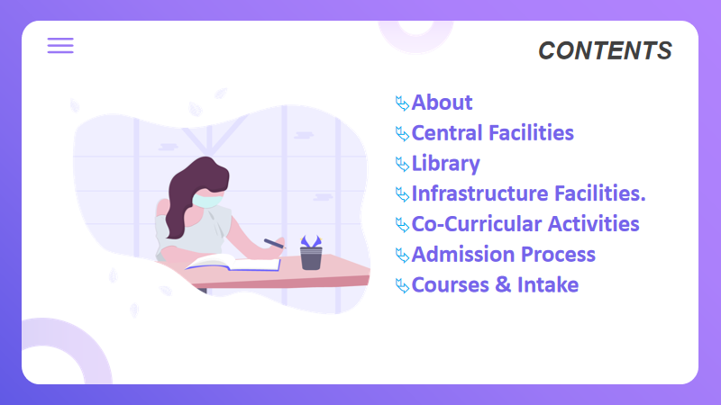



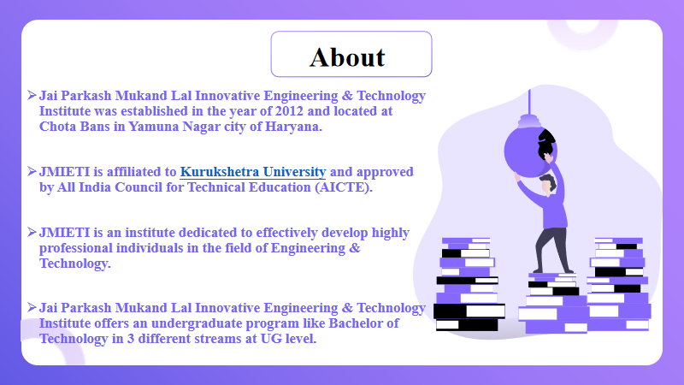

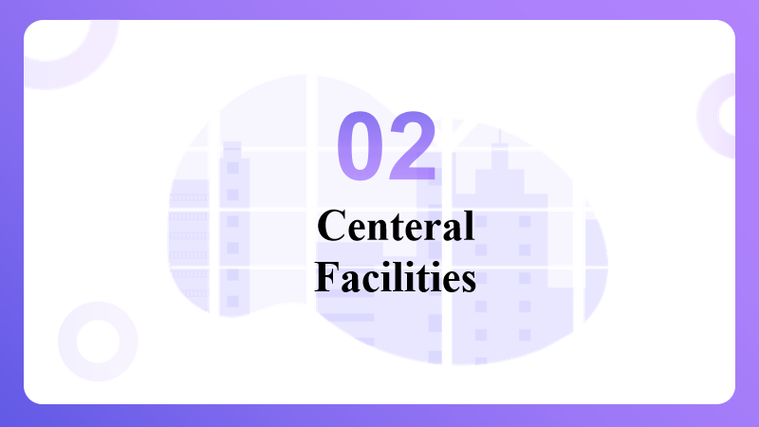

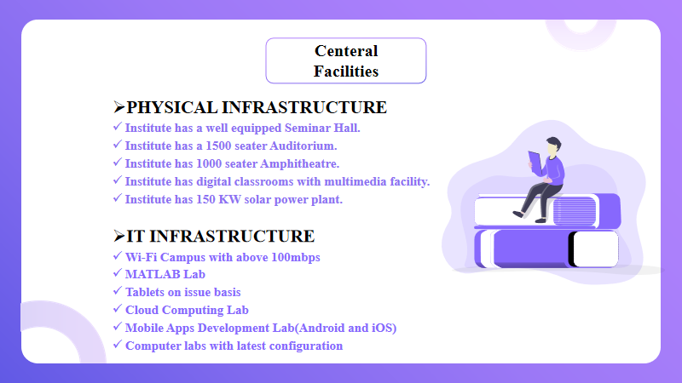

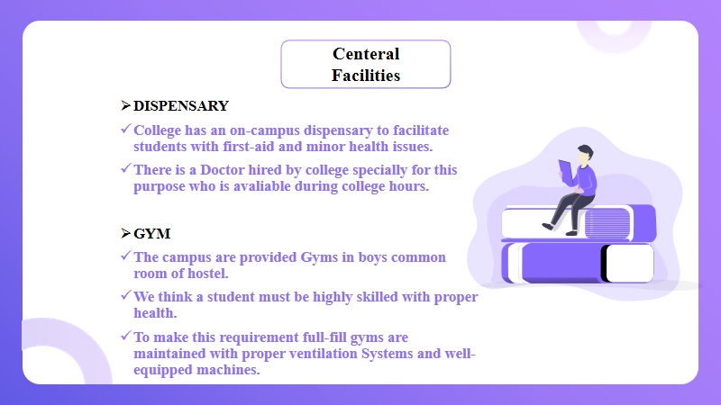

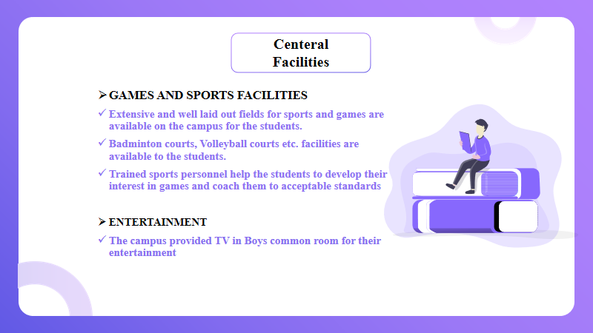

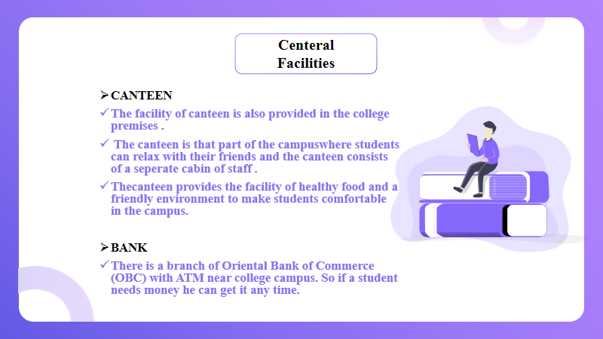

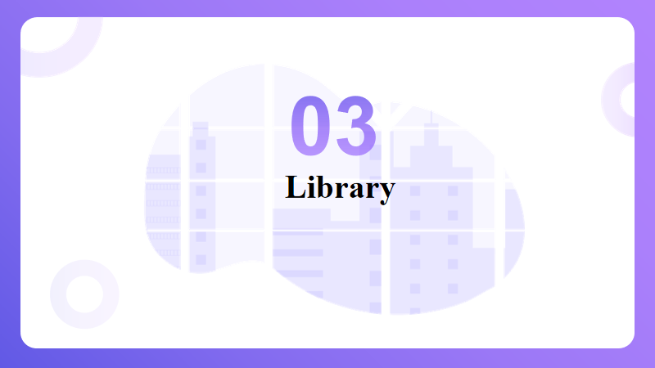

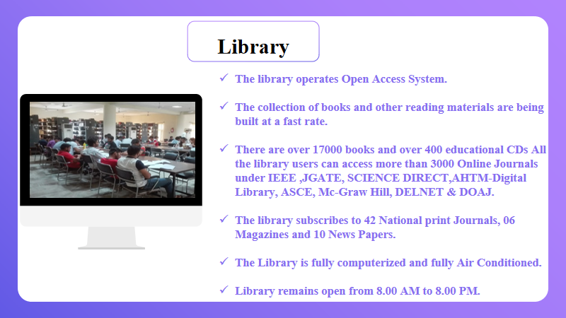

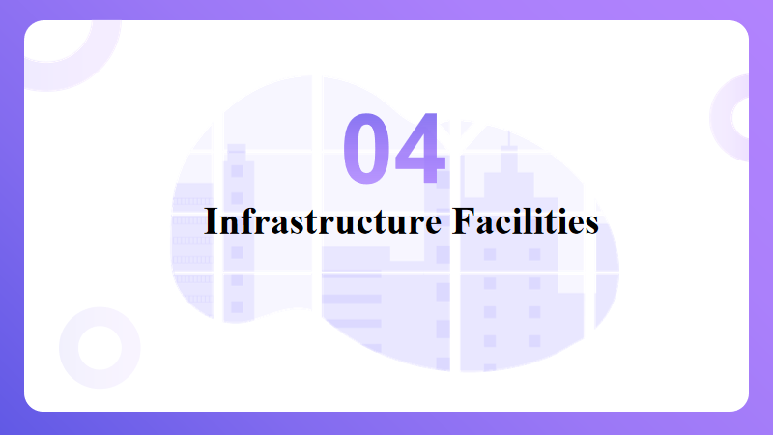

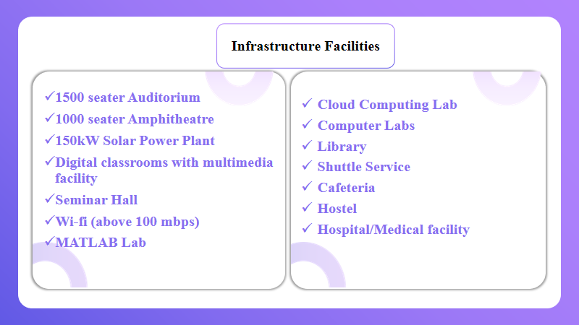

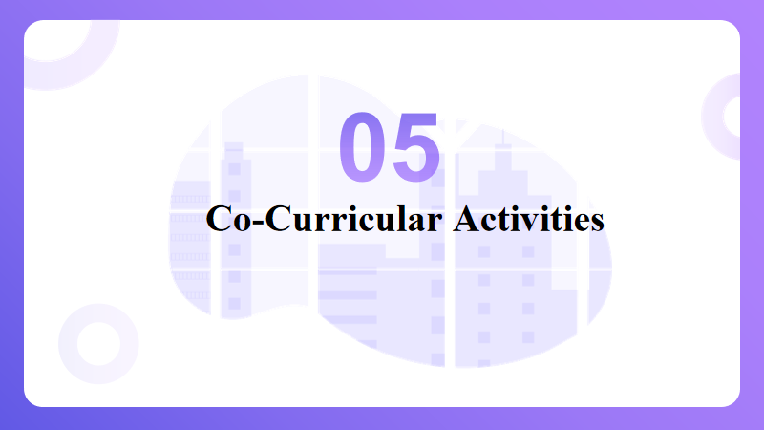

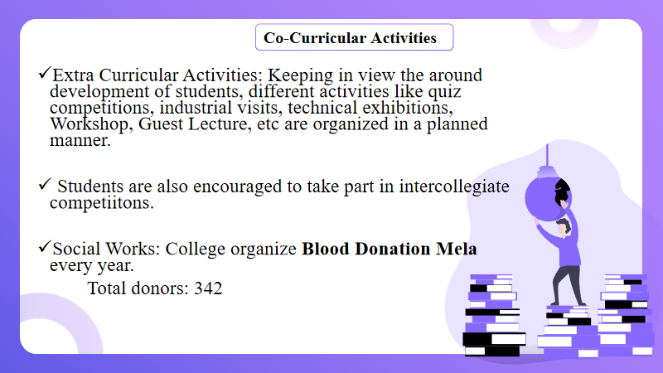

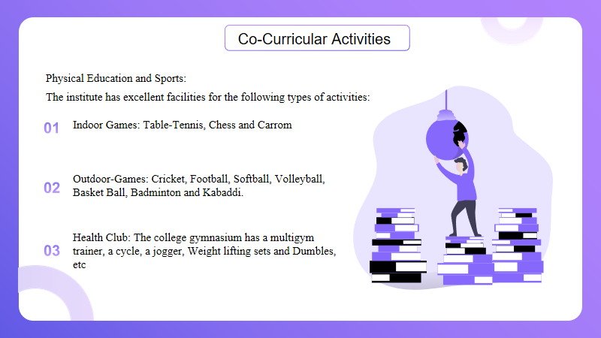

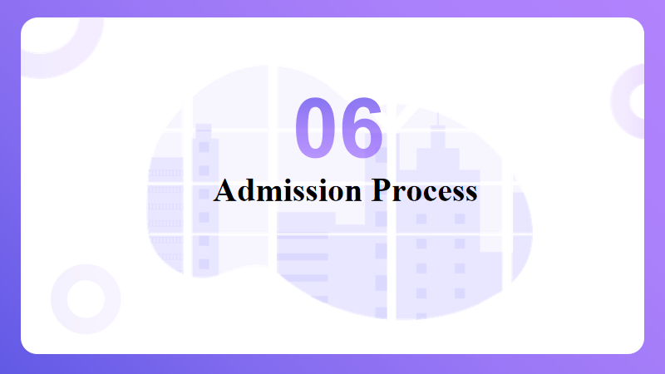

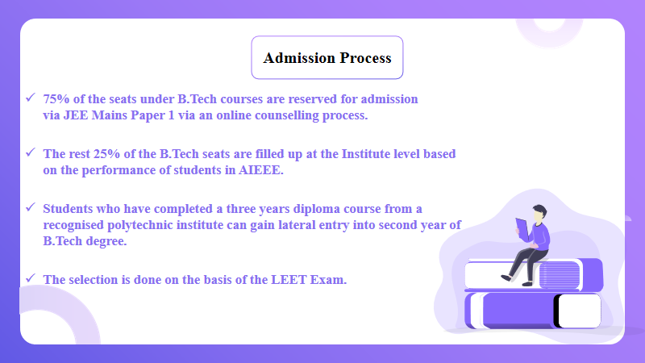



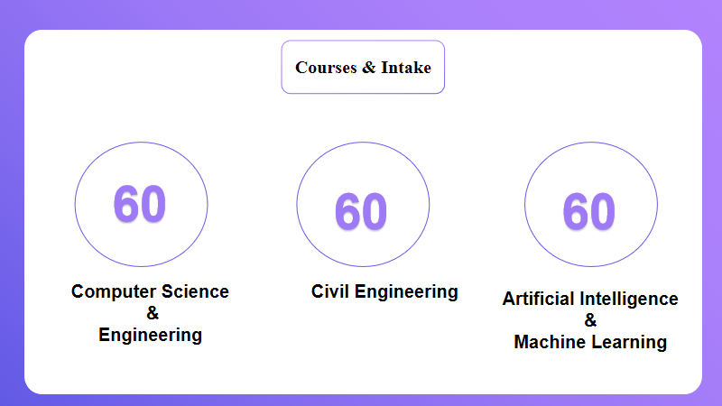

**Practical - 4**

**Objective:** Create a new document that take the format of business letter. Combine <P> and <BR> tags to properly separate the different part of the document. Such as the address, greeting,content and signature. What works best for each?

**Description:** The Paragraph element. The <p> HTML element represents a paragraph. Paragraphs are usually represented in visual media as blocks of text separated from adjacent blocks by blank lines and/or first-line indentation, but HTML paragraphs can be any structural grouping of related content, such as images or form fields.

The <br> HTML element produces a line break in text (carriage-return). It is useful for writing a poem or an address, where the division of lines is significant.

Tag omission

Permitted content

Implicit ARIA role

Permitted parents

**Source Code:**

<html>

<head>

    <title>Bussiness Letter</title>

</head>

<body bgcolor=" #f7f7f7">

    <p>

    <h1 align="center"> BUSINESS THANK YOU LETTER</h1>

    <h4>From,</h4>

    <h4>Jack Abel</h4>

    <h4>98/98 Tincidunt Street</h4>

    <h4>Indiana 13546</h4>

    <h4>(866) 564-566</h4>

    <br>

    <h5>Date: 15-08-1999</h5>

    <br>

    <h4>To,</h4>

    <h4>Walter Abel</h4>

    <h4>65/989 Arch Park</h4>

    <h4>Georgia 75478</h4>

    <p>

Our company, [name of your organization] is willing to take this opportunity to thank you for closely working with us in our technical department. The insights and the innovative methods incorporated by your team were

really appreciated as these will surely be resourceful for our organization in the future.

Mention about certain details of your organization and the company you recently worked with. The [mention about

some activities] performed during this collaboration were specifically informative and helpful.

We are looking ahead for a fruitful relationship between both of our companies. We can also discuss various

business opportunities that can be helpful for both of our organizations. It has really been a pleasure

conducting business with your company.

</p>

    <h4>Sincerely</h4>

    <br>

    <h5>[Signature]</h5>

    <h4>jack Abel</h4>

    </p>

</body>

</html>

**Output:**

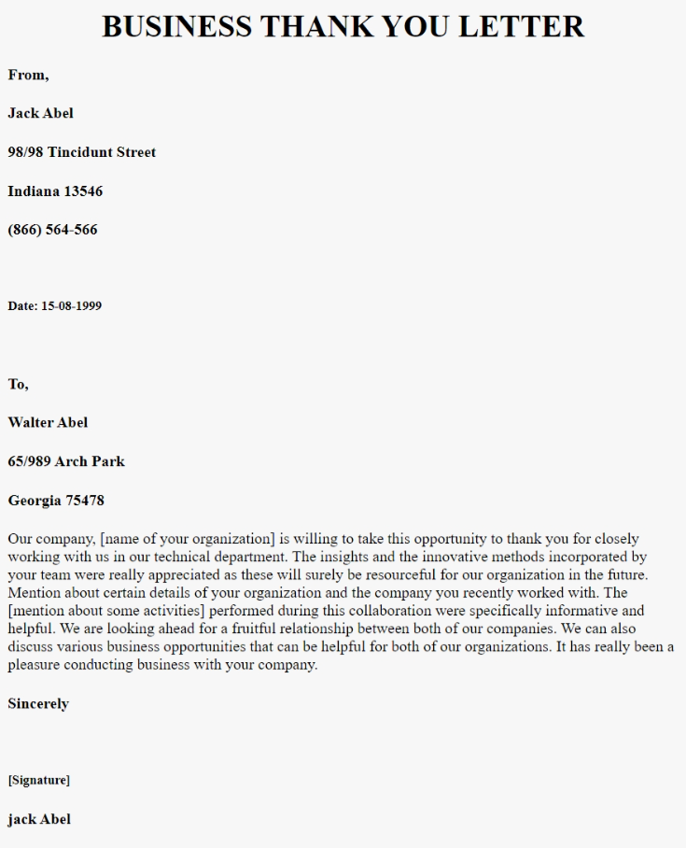

***Business Letter***

**Practical - 6**

**Objective:** Create a new document that uses <PRE> tag to work as an invoice or bill of scale,complete with aligned dollar values and a total. Remember not to use the Tab key,and avoid using tags like <b> or <EM> within your list.

**Description:** The Preformatted Text element. The <pre> HTML element represents preformatted text which is to be presented exactly as written in the HTML file. The text is typically rendered using a non-proportional, or monospaced, font.

To bold the text in HTML, use either the strong tag or the b (bold) tag. Browsers will bold the text inside both of these tags the same, but the strong tag indicates that the text is of particular importance or urgency. You can also bold text with the CSS font-weight property set to “bold.

The <em> HTML element marks text that has stress emphasis. The <em> element can be nested, with each level of nesting indicating a greater degree of emphasis.

Tag omission

DOM interface

Permitted parents

Permitted content

**Source Code:**

<html>

<head>

    <title>Invoice</title>

</head>

<body bgcolor="#f7f7f7" width="50%">

    <pre>

        <h1 align="center">Invoice</h1>

        <hr>

        KOICE                                            Invoice

    <hr>

    Date : 05/12/2020                                    Invoice No : 16835

    <hr>

    Invoice To :                                           Pay To :

    Smith Rhodas                                          Koice inc

    15 Hodgos Mows,High Whycombo                           2075 N Enterprise

    HP123JL                                               Orange CA 92865

    United Kingdom                                        contact@Koice.com

    <hr>

    |   Services       |        Description         |  Rate     |  QTY   |   Amount   |

    <hr>

    |   Design         |  Website Design            | $50.00   |   10   |  $500.00   |

    |   Devlopment    |  Website Devlopmet        | $120.00 |   10   |  $1200.00  |

    |   SEO            |  SEO                       | $450.00 |   10   |  $450.00   |

   <hr>

                                                     Sub Total    :  $2150.00

 <hr>

                                                         Tax      :   $215.00

</pre>

</body>

</html>

**Output:**

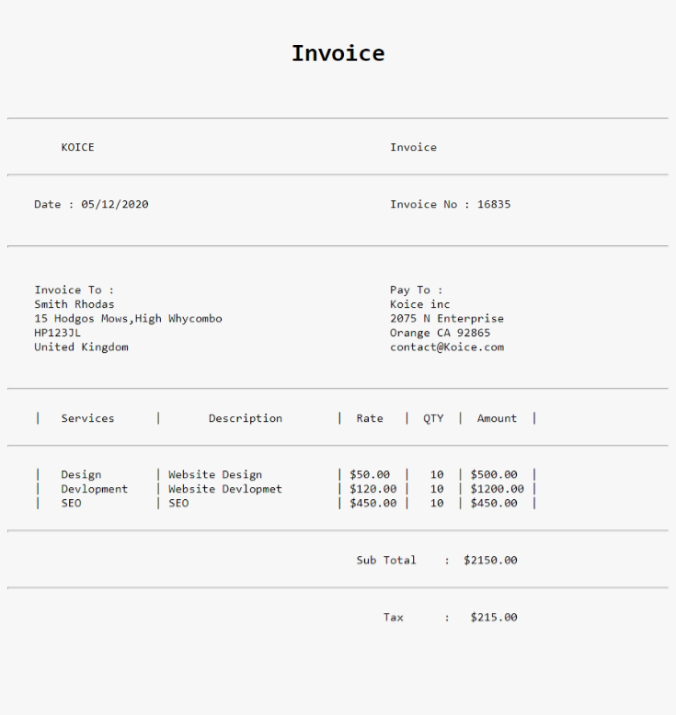

***Invoice***

**Practical - 7**

**Objective:** Create a seven-item ordered list using Roman numerals. After the fifth item, Increase the next list value by 5.

**Description**: The <li> HTML element is used to represent an item in a list. It must be contained in a parent element: an ordered list ( <ol> ), an unordered list ( <ul> ), or a menu ( <menu> ). In menus and unordered lists, list items are usually displayed using bullet points.

Tag omission

Permitted parents

**Source Code:**

<html >

<head>

    <title>List</title>

</head>

<body bgcolor="#f7f7f7">

    <h1>Orders List With Skip</h1>

    <ol type="i">

        <li>One</li>

        <li>Two</li>

        <li>Three</li>

        <li>Four</li>

        <li>Five</li>

        <li value="11">Six</li>

        <li value="12">Seven</li>

    </ol>

</body>

</html>

**Output:**

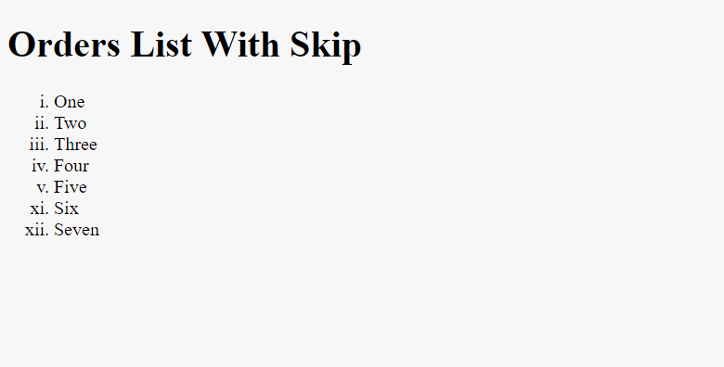

***Order List With Skip***

**Practical - 8**

**Objective:** Beginning with an ordered list, create a list that nests both an unordered list and a definition list.

**Description:** The <li> HTML element is used to represent an item in a list. It must be contained in a parent element: an ordered list ( <ol> ), an unordered list ( <ul> ), or a menu ( <menu> ). In menus and unordered lists, list items are usually displayed using bullet points.

Tag omission

Permitted parents

The <dt> HTML element specifies a term in a description or definition list, and as such must be used inside a <dl> element. It is usually followed by a <dd> element; however, multiple <dt> elements in a row indicate several terms that are all defined by the immediate next <dd> element.

Permitted parents

Tag omission

DOM interface

Permitted content

**Source Code:**

<html>

<head>

    <title>Operating System</title>

</head>

<body bgcolor="#f7f7f7">

    <h1 align="center">Different Operating System</h1>

    <ol>

        <li>MS-DOS</li>

        <li> Windows Operating System</li>

        <li> LINUX Operating System

            <ul>

                <dl>

                    <dt>Red Hat Linux</dt>

         <img src="https://technadvice.com/wp-content/uploads/2020/04/Red-Hat Linux.png " width="96px"

                        alt="image">

                    <dd>The RedHat Linux operating system is one of the relatively old GNU / Linux, offering

                        convenience, a fully graphical display mode starting at installation, and friendly usage.

                    </dd>

                </dl>

                <dl>

                    <dt>Debian Linux</dt>

  <img src="https://technadvice.com/wp-content/uploads/2020/04/Debian-Linux.jpg" width="96px"

                        alt="image">

                    <dd>TDebian is one type of various Linux operating systems that have been around for a long time since 1999 and continue to be developed regularly every year until now entering version 8.

                    </dd>

                </dl>

                <dl>

                    <dt> Ubuntu Linux</dt>

 <img src="https://technadvice.com/wp-content/uploads/2020/04/Ubuntu-Linux.jpg" width="96px"

                        alt="image">

                    <dd>Ubuntu is a type of Linux operating system that is basically developed from Debian. The difference is that this Ubuntu operating system can be used not only on server computers and admin computers but also can and is suitable for use on personal or personal computers. The Ubuntu project itself is funded by Canonical Ltd (a company owned by Mark Shuttleworth).

                    </dd>

                </dl>

                <dl>

                    <dt>Linux Mint</dt>

 <img src="https://technadvice.com/wp-content/uploads/2020/04/Linux-Mint.jpg" width="96px"

                        alt="image">

                    <dd>If Ubuntu was a development of Debian, Linux Mint is arguably the grandchild of Debian because it was developed on the basis of Ubuntu. The Linux Mint operating system was developed for the purpose of personal or personal use (PC) and is divided into 2 variants namely CINNAMON and MATE.

                    </dd>

                </dl>

                <dl>

                    <dt>Red Hat Linux</dt>

 <img src="https://technadvice.com/wp-content/uploads/2020/04/Fedora-Linux.jpg" width="96px"

                        alt="image">

                    <dd>Fedora (formerly called Fedora Core, sometimes also called Fedora Linux) is an RPM-based Linux distribution that is developed by the Fedora Project which is supported by the programming community and sponsored by Red Hat. The latest version is Fedora 24.

                    </dd>

                </dl>

            </ul>

        </li>

        <li>Solaris Operating System</li>

        <li>Symbian Operating System</li>

        <li>Android Mobile Operating System

            <ul>

                <li>Android 1.5, Cupcake: April 27, 2009</li>

                <li>Android 1.6, Donut: September 15, 2009</li>

                <li>Android 2.0-2.1, Eclair: October 26, 2009 (initial release)</li>

                <li>Android 2.2-2.2.3, Froyo: May 20, 2010 (initial release)</li>

                <li>Android 2.3-2.3.7, Gingerbread: December 6, 2010 (initial release)</li>

                <li>Android 3.0-3.2.6, Honeycomb: February 22, 2011 (initial release)</li>

                <li>Android 4.0-4.0.4, Ice Cream Sandwich: October 18, 2011 (initial release)</li>

                <li>Android 4.1-4.3.1, Jelly Bean: July 9, 2012 (initial release)</li>

                <li>Android 4.4-4.4.4, KitKat: October 31, 2013 (initial release)</li>

                <li>Android 5.0-5.1.1, Lollipop: November 12, 2014 (initial release)</li>

                <li>Android 6.0-6.0.1, Marshmallow: October 5, 2015 (initial release)</li>

                <li>Android 7.0-7.1.2, Nougat: August 22, 2016 (initial release)</li>

                <li>Android 8.0-8.1, Oreo: August 21, 2017 (initial release)</li>

                <li>Android 9.0, Pie: August 6, 2018</li>

                <li>Android 10.0: September 3, 2019</li>

                <li>Android 11.0: September 8, 2020 </li>

            </ul>

        </li>

        <li>iOS Mobile Operating System</li>

    </ol>

</body>

</html>

**Output:**

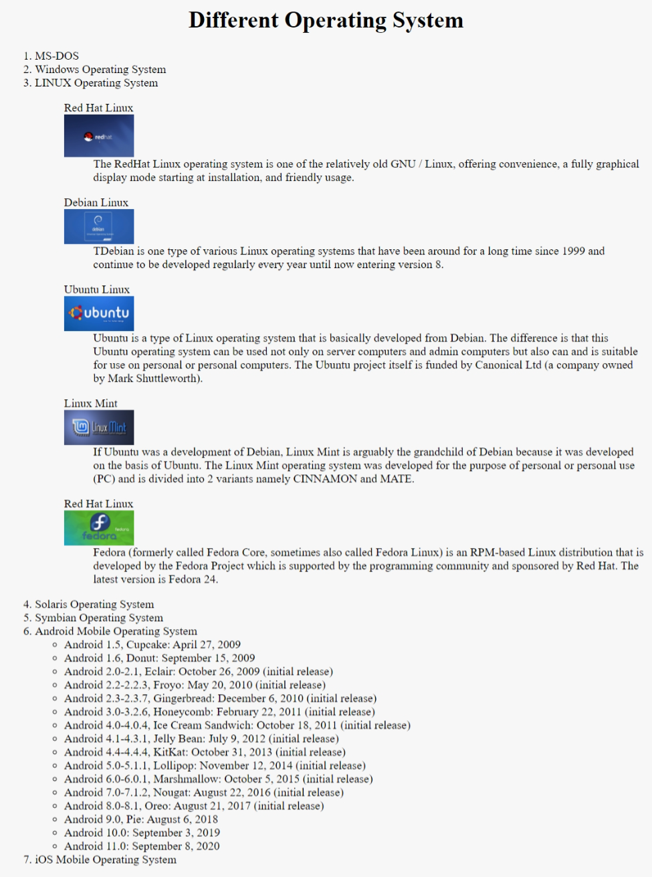

***Nesting List***

**Practical -9**

**Objective:** Use the AlIGN attribute of an <IMG> tags to align another image to the top of the first image play with this feature,aligning imges TOP, MIDDLE and BOTTOM

**Description:** The <img> tag is used to embed an image in an HTML page. Images are not technically inserted into a web page; images are linked to web pages. The <img> tag creates a holding space for the referenced image.

**Source Code:**

**09A_ImageTop.html**

<html>

<head>

    <title>Top</title>

</head>

<body>

    <h1>Top</h1>

    <a href="08B_ImageMiddle.html">

        <img src="android.jpg" alt="" height="240" hspace="440">

    </a>

</body>

</html>

**09B_ImageMiddle.html**

<html>

<head>

    <title>Middle</title>

</head>

<body>

    <h1>Middle</h1>

    <a href="08C_ImageBottom.html"><img src="android.jpg" alt=""

            height="240" hspace="540" vspace="240"></a>

</body>

</html>

**09C_ImageBottom.html**

<!DOCTYPE>

<html>

<head>

    <title>Bottom</title>

</head>

<body>

    <h1>Bottom</h1>

    <a href="08A_imageTop.html"><img src="android.jpg" alt=""

            height="240"

            hspace="540"

            vspace="540"></a>

</body>

</html>

**Output:**

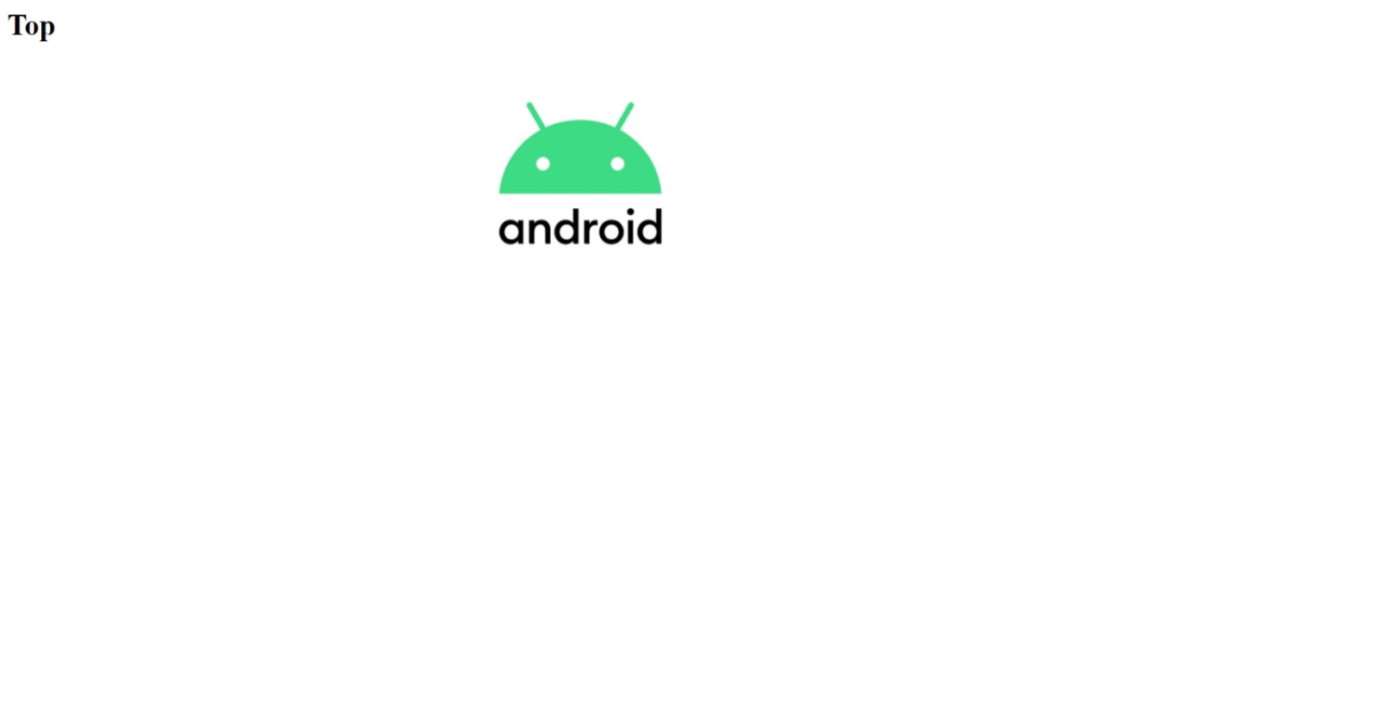

***Image Top***

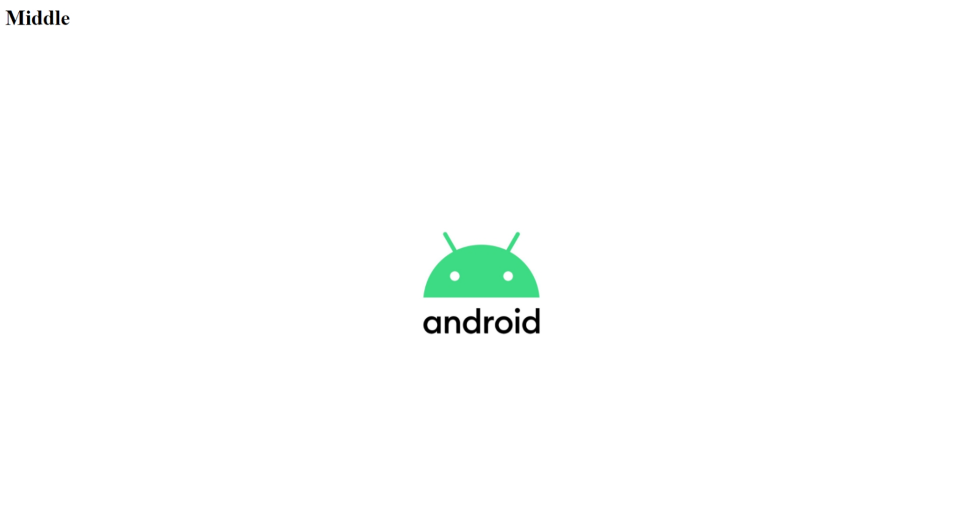

***Image Middel***

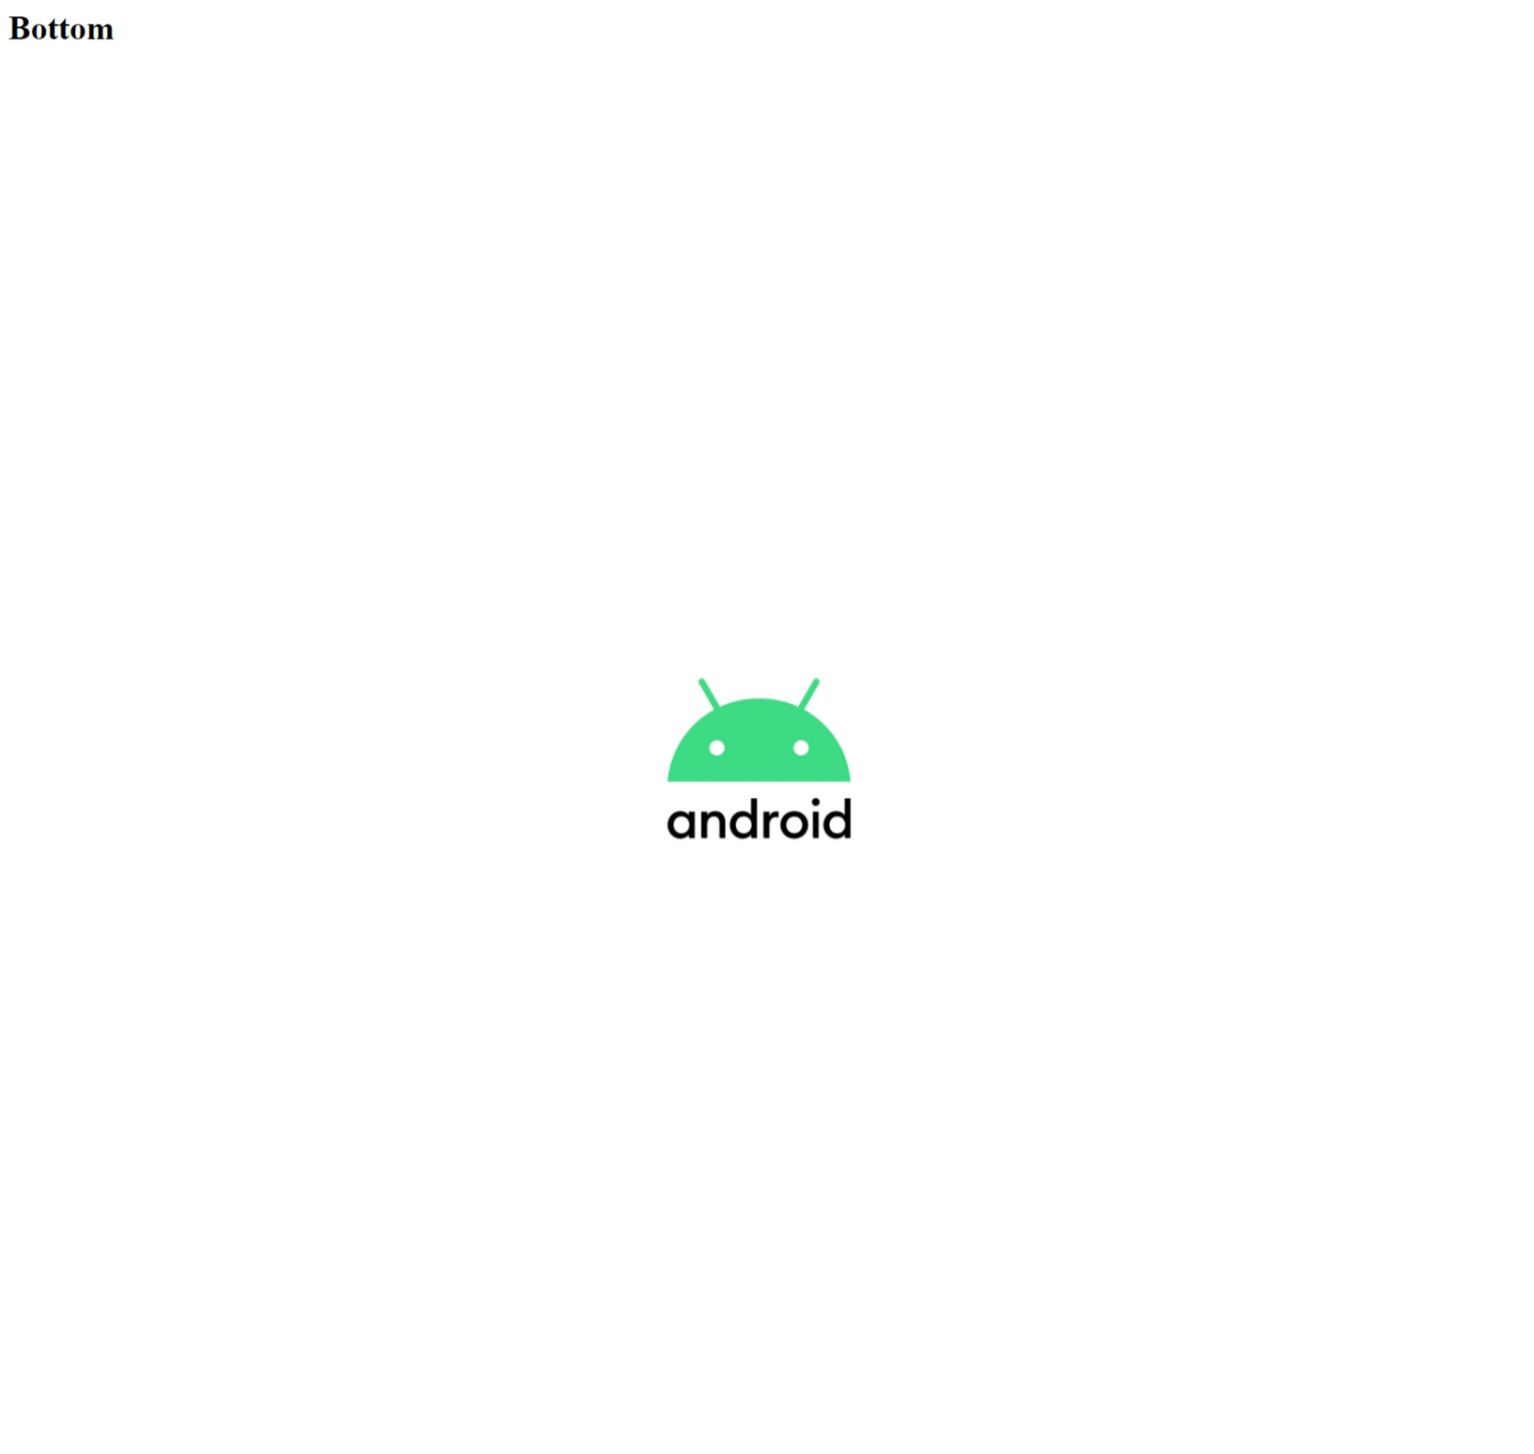

***Image Bottom***

**Practical - 10**

**Objective:**Program To prepare a Web-page of Invoice using table Tag.

**Description**: The <td> tag defines a standard data cell in an HTML table. An HTML table has two kinds of cells: Header cells - contains header information (created with the <th> element) Data cells - contains data (created with the <td> element).

The <tr> tag defines a row in an HTML table. A <tr> element contains one or more <th> or <td> elements.

The <th> tag defines a header cell in an HTML table. An HTML table has two kinds of cells: Header cells - contains header information (created with the <th> element) Data cells - contains data (created with the <td> element)

**Source Code:**

<html>

<head>

    <title>Tables</title>

</head>

<body>

    <h1 align="center">Invoice</h1>

    <table border="2" align="center" cellpadding="5" cellspacing="5" bgcolor="#f7f7f7" width="80%">

        <tbody align="left">

            <tr>

                <th>Koice</th>

                <th>Invoice</th>

            </tr>

            <tr>

                <td>Date :05/15/2020</td>

                <td>Invoice No : 16835</td>

            </tr>

            <tr>

                <td>Invoice To:<br>

                    Smith Rhodoes<br>

                    15 Hodges Mows<br>

                    Hp123Jl<br>

                    United State

                </td>

                <td>Pay To:<br>

                    Koice Inc<br>

                    2705 N Enterprise St<br>

                    Orange Ca 92865<br>

                   Contact@koiceinc.com</td>

            </tr>

        </tbody>

    </table>

    <table border="2" align="center" cellpadding="5" cellspacing="5" bgcolor="#f7f7f7" width="80%">

        <caption>Invoice</caption>

        <br>

        <thead>

            <td colspan="5" align="center">Details</td>

            </tr>

        </thead>

        <tbody align="center">

            <tr>

                <th>Services</th>

                <th>Description</th>

                <th>Rate</th>

                <th>QTY</th>

                <th>Amount</th>

            </tr>

            <tr>

                <td>Design</td>

                <td>Creating a Website Desiggn</td>

                <td>$50.00</td>

                <td>10</td>

                <td>$500.00 </td>

            </tr>

            <tr>

                <td>Devlopment</td>

                <td>Website Devlopment</td>

                <td>$120.00</td>

                <td>10</td>

                <td>$1200.00</td>

            </tr>

            <tr>

                <td>SEO</td>

                <td>Optimse</td>

                <td>$450.00</td>

                <td>1</td>

                <td>$450.00</td>

            </tr>

            <tr>

                <td>-</td>

                <td> </td>

                <td>-</td>

                <td>-</td>

                <td>-</td>

            </tr>

            <tr>

                <td>-</td>

                <td> </td>

                <td>-</td>

                <td>-</td>

                <td>-</td>

            </tr>

            <tr>

                <td>-</td>

                <td> </td>

                <td>-</td>

                <td>-</td>

                <td>-</td>

            </tr>

            <tr>

                <td>-</td>

                <td> </td>

                <td>-</td>

                <td>-</td>

                <td>-</td>

            </tr>

            <tr>

                <td colspan="4"> Sub Total</td>

                <td>$2150.00</td>

            </tr>

            <tr>

                <td colspan="4"> Tax:</td>

                <td>$215.00</td>

            </tr>

        </tbody>

        <tfoot>

            <td colspan="5" align="center">ThankYou For Your Bussiness</td>

        </tfoot>

    </table>

</body>

</html>

**Output:**

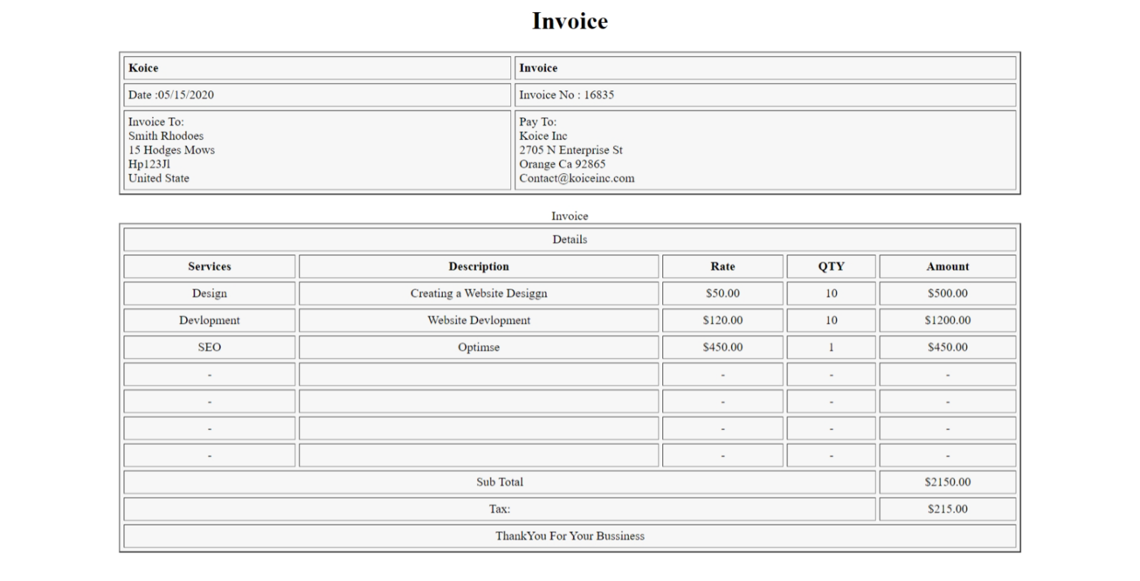

***Invoice Using Tabel***

**Practical - 11**

**Objective:** Program to prepare a web-page to contain table that loads different documents after clicking their content.

**Description:** The <table> tag defines an HTML table. An HTML table consists of one <table> element and one or more <tr>, <th>, and <td> elements. The <tr> element defines a table row, the <th> element defines a table header, and the <td> element defines a table cell.

**Source Code:**

<html>

<head>

    <title>Table Of Content</title>

</head>

<body>

    <h1 align="center">Differnet Document List</h1>

    <table border="2" align="center" cellpadding="5" cellspacing="5" bgcolor="#f7f7f7" width="80%">

        <br>

        <thead>

            <td colspan="4" align="center">Table Of Content</td>

            </tr>

        </thead>

        <tbody align="center">

            <tr>

                <th>Sr. No.</th>

                <th>Topic</th>

            </tr>

            <tr>

                <td>1</td>

                <td>

                    <a href="01Bio - Data.docx">Resume/Biodata</a>

                </td>

            </tr>

            <tr>

                <td>2</td>

                <td>

                    <a href="02Result.xlsx">Result Graph In Excel</a>

                </td>

            </tr>

            <tr>

                <td>3</td>

                <td>

                    <a href="03CollagePresentation.pptx">Presentation On Collage</a>

                </td>

            </tr>

            <tr>

                <td>4</td>

                <td>

                    <a href="04BussinesLetter.html">Bussiness Letter template</a>

                </td>

            </tr>

            <tr>

                <td>5</td>

                <td>

                    <a href="05Innvoice.html">Invoice</a>

                </td>

            </tr>

            <tr>

                <td>6</td>

                <td>

                    <a href="06List.html"> List Jump</a>

                </td>

            </tr>

            <tr>

                <td>7</td>

                <td>

                    <a href="07listOS.html">Orderd List</a>

                </td>

            </tr>

            <tr>

                <td>8</td>

                <td>

                    <a href="08A_imageTop.html">Image Illustion</a>

                </td>

            </tr>

            <tr>

                <td>9</td>

                <td>

                    <a href="09InnvoiceUsingTable.html"> Invoice Using table</a>

                </td>

            </tr>

            <tr>

                <td>10</td>

                <td>

                    <a href="10Table_of_Content.html">Table Of Cotent</a>

                </td>

            </tr>

            <tr>

                <td>*</td>

                <td>

                    <a href="android.jpg"> Android Logo</a>

                </td>

            </tr>

            <tr>

                <td>*</td>

                <td>

                    <a href="ITM file.docx"> Internet Technology Management Lab Doc File</a>

                </td>

            </tr>

            <tr>

                <td>*</td>

                <td>

                    <a href="ITM file.pdf"> Internet Technology Management Lab PDF File</a>

                </td>

            </tr>

        </tbody>

        <tfoot>

            <td colspan="4" align="center">Thank You</td>

        </tfoot>

    </table>

</body>

</html>

**Output:**

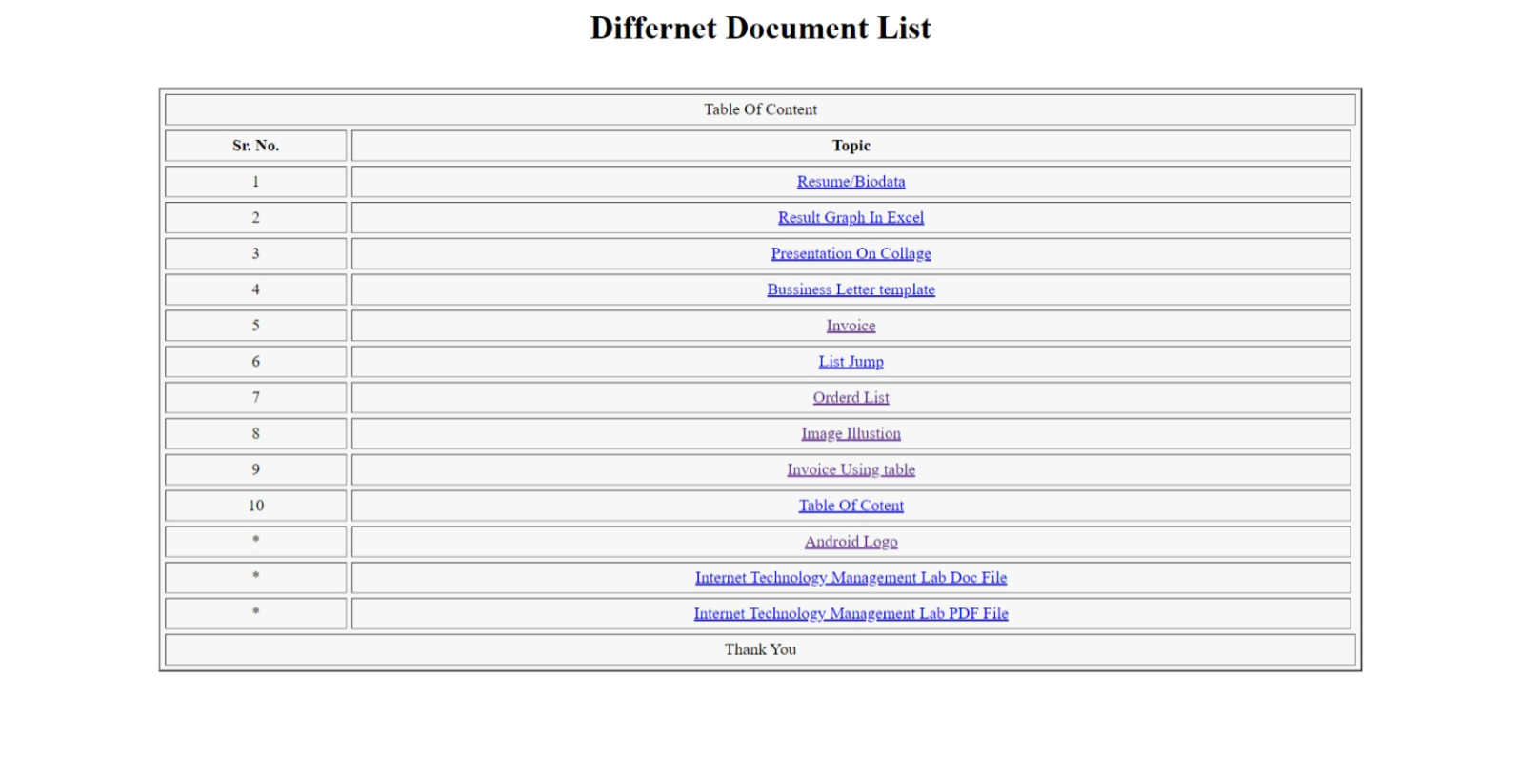

***Tabel of Content***

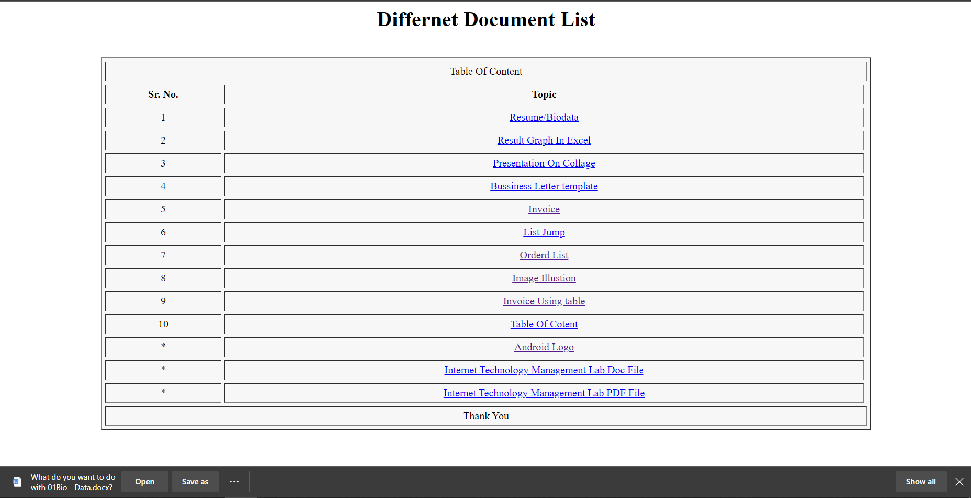

***If we open file which not open in browser it will downloaded***



***When we click on Android Logo it will open in browser***



***When we click on Pdf it will open in browser***

**Practical - 12**

**Objective:** Program to Prepare a web-page to illustrate interlinking ,Interlinking and Hyper Linking.

**Description:** HTML internal link is linked within the same web page. This link can be an absolute path or relative path. HTML internal link name is followed by the hash sign(#). You have to assign an id to refer section of your page, which is referred to as an internal link to the same page.

Intrapage linking enables you to have a link in a document that will automatically go to another location within the same document.

To make a hyperlink in an HTML page, use the <a> and </a> tags, which are the tags used to define the links. The <a> tag indicates where the hyperlink starts and the </a> tag indicates where it ends. Whatever text gets added inside these tags, will work as a hyperlink. Add the URL for the link in the <a href=” ”>

**Source Code:**

<html>

<head>

     <title> Linking In Web Pages </title>

</head>

<body>

     <h3> Inter Linking </h3>

     <a href="#redhat"> Red hat Linux </a>

     <a href="#debian"> Debian Linux </a>

     <a href="#ubantu"> Ubuntu Linux </a>

     <h3> Intra Linking </h3>

     <a href="08A_imageTop.html">Image Illusision game </a>

     <h3> Hyper Linking </h3>

     <a href="https://www.jmieti.edu.in/">Collage Website</a>

     <ul>

          <dl>

               <dt id="redhat">Red Hat Linux</dt>

               <img src="https://technadvice.com/wp-content/uploads/2020/04/Red-Hat-Linux.png " width="96px" alt="">

               <dd>The RedHat Linux operating system is one of the relatively old GNU / Linux, offering

                    convenience, a fully graphical display mode starting at installation, and friendly usage.

                    <br>

          Linux® is an open source operating system (OS). It was originally conceived of and created as a

          hobby by Linus Torvalds in 1991. Linus, while at university, sought to create an alternative, free,

         open source version of the MINIX operating system, which was itself based on the principles and

                    design of Unix.

                    <br>

            That hobby has since become the OS with the largest user base, the most-used OS on publicly

                    available internet servers, and the only OS used on the top 500 fastest supercomputers.

                    <br>

     Perhaps the best thing about Linux is that it's open source. Linux is released under the GNU General

           Public License (GPL). That means that anyone can run, study, share, and modify the software.

                    <br>

    The  modified code can also be redistributed, and even sold, but must be done so under the same license.This differs greatly from traditional operating systems—Unix and Windows, for example—which are proprietary, locked-down, and delivered as-is and unmodifiable.

               </dd>

          </dl>

          <dl>

               <dt id="debian">Debian Linux</dt>

               <img src="https://technadvice.com/wp-content/uploads/2020/04/Debian-Linux.jpg" width="96px" alt="">

               <dd>TDebian is one type of various Linux operating systems that have been around for a long time since 1999 and continue to be developed regularly every year until now entering version 8.

                    <br>

                    Linux® is an open source operating system (OS). It was originally conceived of and created as a  hobby by Linus Torvalds in 1991. Linus, while at university, sought to create an alternative, free,

 open source version of the MINIX operating system, which was itself based on the principles and

                    design of Unix.

                    <br>

                    That hobby has since become the OS with the largest user base, the most-used OS on publicly available internet servers, and the only OS used on the top 500 fastest supercomputers.

                    <br>

                    Perhaps the best thing about Linux is that it's open source. Linux is released under the GNU General  Public License (GPL). That means that anyone can run, study, share, and modify the software.

                    <br>

                    The

                    modified code can also be redistributed, and even sold, but must be done so under the same license. This differs greatly from traditional operating systems—Unix and Windows, for example—which are proprietary, locked-down, and delivered as-is and unmodifiable.

               </dd>

          </dl>

          <dl>

               <dt id="ubantu"> Ubuntu Linux</dt>

               <img src="https://technadvice.com/wp-content/uploads/2020/04/Ubuntu-Linux.jpg" width="96px" alt="">

               <dd>Ubuntu is a type of Linux operating system that is basically developed from Debian. The difference is  that this Ubuntu operating system can be used not only on server computers and admin computers but  also can and is suitable for use on personal or personal computers. The Ubuntu project itself is   funded by Canonical Ltd (a company owned by Mark Shuttleworth).

                    <br>

                    Linux® is an open source operating system (OS). It was originally conceived of and created as a  hobby by Linus Torvalds in 1991. Linus, while at university, sought to create an alternative, free,

  open source version of the MINIX operating system, which was itself based on the principles and

      design of Unix.

                    <br>

                    That hobby has since become the OS with the largest user base, the most-used OS on publicly  available internet servers, and the only OS used on the top 500 fastest supercomputers.

                    <br>

                    Perhaps the best thing about Linux is that it's open source. Linux is released under the GNU General  Public License (GPL). That means that anyone can run, study, share, and modify the software.

                    <br>

                    The

                    modified code can also be redistributed, and even sold, but must be done so under the same license. This differs greatly from traditional operating systems—Unix and Windows, for example—which are proprietary, locked-down, and delivered as-is and unmodifiable.

               </dd>

          </dl>

     </ul>

</body>

</html>

**08A_ImageTop.html**

<html>

<head>

    <title>Top</title>

</head>

<body>

    <h1>Top</h1>

    <a href="08B_ImageMiddle.html">

        <img src="android.jpg" alt="" height="240" hspace="440">

    </a>

</body>

</html>

**08B_ImageMiddle.html**

<html>

<head>

    <title>Middle</title>

</head>

<body>

    <h1>Middle</h1>

    <a href="08C_ImageBottom.html"><img src="android.jpg" alt=""

            height="240" hspace="540" vspace="240"></a>

</body>

</html>

**08C_ImageBottom.html**

<!DOCTYPE>

<html>

<head>

    <title>Bottom</title>

</head>

<body>

    <h1>Bottom</h1>

    <a href="08A_imageTop.html"><img src="android.jpg" alt=""

            height="240"

            hspace="540"

            vspace="540"></a>

</body>

</html>

**Output:**

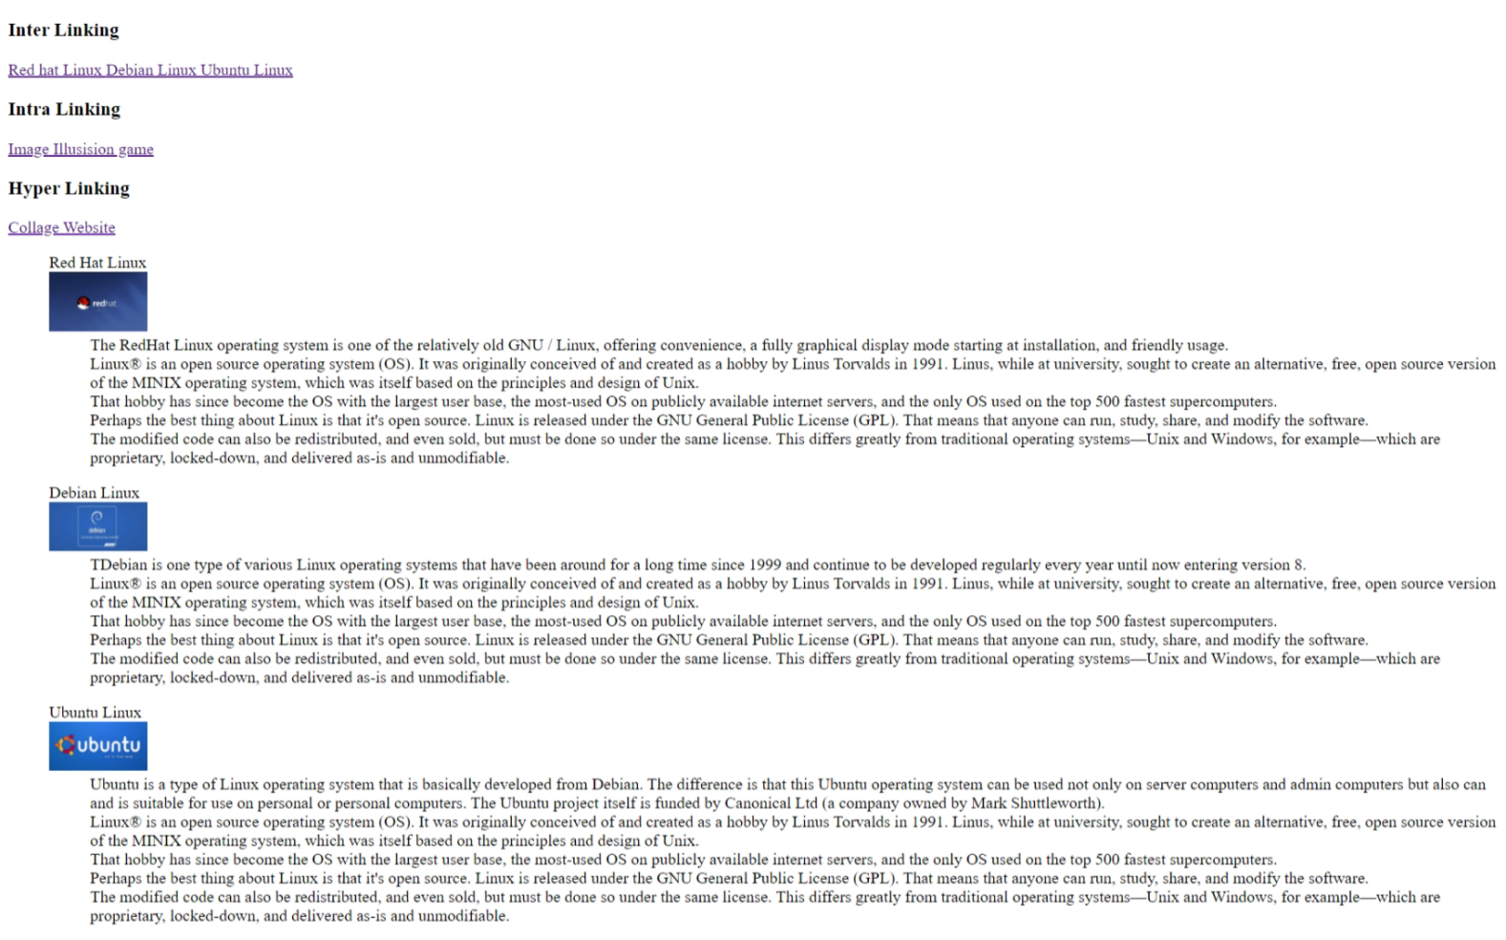

***Landing page***

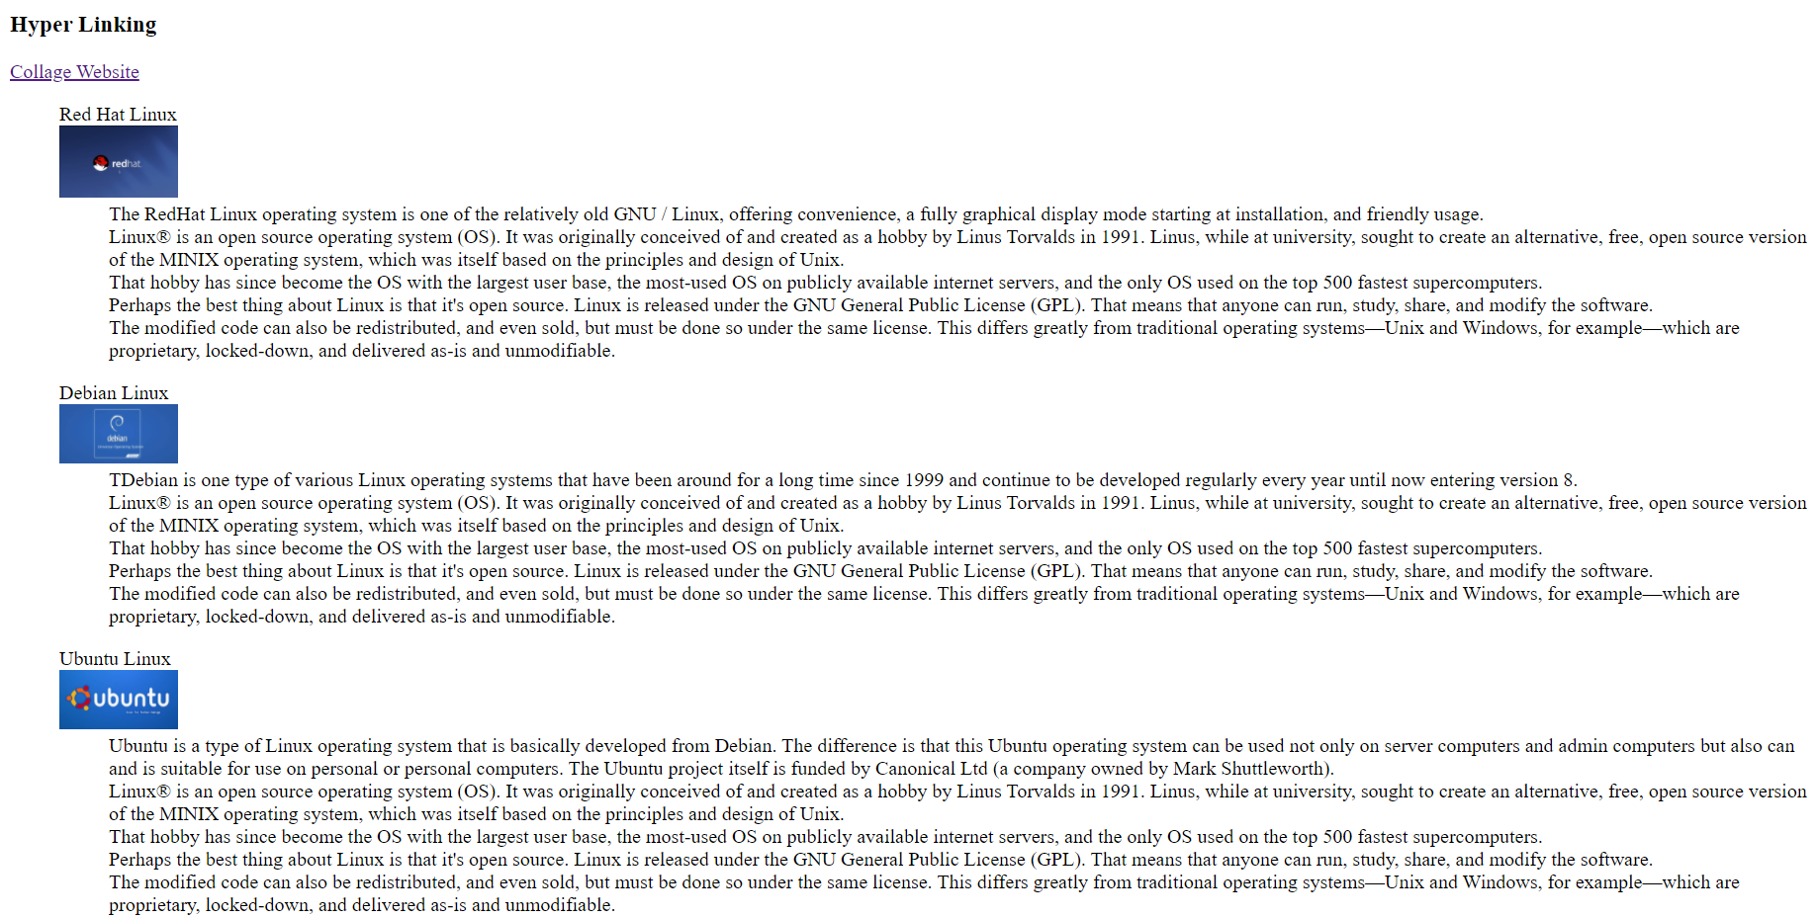

***After Clicking On Red Hat Linux***

***After Clicking On game Illusion***



***Image Top***



***Image Middel***

***Image Bottom***

***After Clicking On Collage Website***

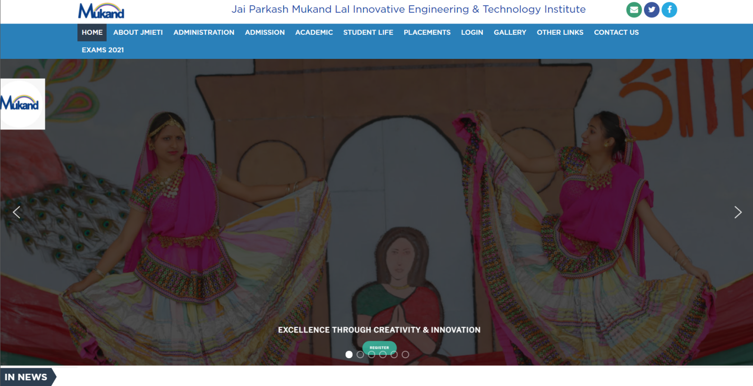

**Practical - 13**

**Objective:** Program to Prepare a web-page to illustrate nested list that include image instead of bullet using data definition list in HTML.

**Description:** A nested list is a list inside another list. You can create a nested unordered list, or a nested ordered list, or even an ordered list nested inside an unordered one. Remember that the only direct child of the ul tag is li.

**Source Code:**

<html>

<head>

    <title>Document</title>

</head>

<body bgcolor="#f7f7f7">

 <h1>Operating Systems</h1>

 <h2>Linux Type</h2>

        <dl>

            <dt>

                <img src="bullet.jfif" alt="" width="25px" height="25px">Red Hat Linux</dt>

            <dd>

                The RedHat Linux operating system is one of the relatively old GNU / Linux, offering

                convenience, a fully graphical display mode starting at installation, and friendly usage.

            </dd>

        </dl>

        <dl>

            <img src="bullet.jfif" alt="" width="25px" height="25px"> Debian Linux</dt>

            <dd>

                TDebian is one type of various Linux operating systems that have been around for a long time since 1999 and continue to be developed regularly every year until now entering version 8.

            </dd>

        </dl>

        <dl>

            <img src="bullet.jfif" alt="" width="25px" height="25px"> Ubuntu Linux</dt>

            <dd>

                Ubuntu is a type of Linux operating system that is basically developed from Debian. The difference is that this Ubuntu operating system can be used not only on server computers and admin computers but also can and is suitable for use on personal or personal computers. The Ubuntu project itself is funded by Canonical Ltd (a company owned by Mark Shuttleworth).

            </dd>

        </dl>

        <dl>

            <img src="bullet.jfif" alt="" width="25px" height="25px"> Linux Mint</dt>

            <dd>

                If Ubuntu was a development of Debian, Linux Mint is arguably the grandchild of Debian because it was developed on the basis of Ubuntu. The Linux Mint operating system was developed for the purpose of personal or personal use (PC) and is divided into 2 variants namely CINNAMON and MATE.

</dd>

        </dl>

        <dl>

            <img src="bullet.jfif" alt="" width="25px" height="25px"> Fedora Linux</dt>

            <dd>

                Fedora (formerly called Fedora Core, sometimes also called Fedora Linux) is an RPM-based Linux distribution that is developed by the Fedora Project which is supported by the programming community and sponsored by Red Hat. The latest version is Fedora 24.

            </dd>

        </dl>

</body>

</html>

**Output:**

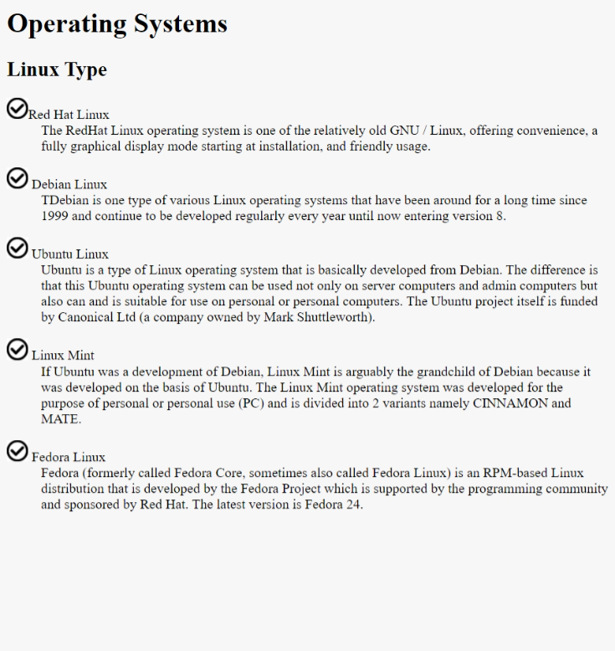

***Image instead of Bullets***

**Practical - 14**

**Objective :** Program to Prepare a web-page using frame.

**Description:** HTML frames are used to divide your browser window into multiple sections where each section can load a separate HTML document. A collection of frames in the browser window is known as a frameset. The window is divided into frames in a similar way the tables are organized: into rows and columns.

**Source Code:**

**index.html**

<html>

    <head>

        <title>Frames </title>

</head>

    <frameset rows="10%,*">

        <frame src="13title.html">

        <frameset cols="25  %,*">

            <frame src="13list.html"/>

            <frame name="frame_set" src="13deafult.html"/>

        </frameset>

    </frameset>

</html>

**title.html**

<html>

<head>

    <title>Tile</title>

</head>

<body bgcolor="#f7f7f7">

    <h1 align="center">Operating Systems</h1>

</body>

</html>

**list.html**

<html>

<head>

    <title>Operating System</title>

</head>

<body bgcolor="#f7f7f7">

    <h1 align="center">Different Operating System</h1>

    <hr>

    <hr>

    <h3>

        <ol>

            <li> <a href="windows.html" target="frame_set">Windows Operating System</a></li>

            <li> <a href="linux.html" target="frame_set">LINUX Operating System</a></li>

            <li> <a href="solaris.html" target="frame_set">Solaris Operating System</a></li>

            <li> <a href="android.html" target="frame_set">Android Mobile Operating System</a></li>

            <li> <a href="ios.html" target="frame_set">iOS Mobile Operating System</a></li>

        </ol>

    </h3>

    <hr>

    <hr>

</body>

</html>

**default.html**

<html >

<head>

    <title>Image</title>

</head>

<body>

    <img src="https://4.bp.blogspot.com/-wQnehwh4nf4/VKoefch5O9I/AAAAAAAAAOs/mUhf0kTu0AQ/s1600/Operating%2BSystems.jpg"

width="1100" height="612" alt=" A image Here">

</body>

</html>

**windows.html**

<html>

<head>

    <title>Windows</title>

</head>

<body bgcolor="#f7f7f7">

    <h1 align="center">Windows</h1>

    <hr>

    <hr>

    <p align="center">Windows is an operating system designed by Microsoft to be used on a standard x86 Intel and AMD processors. It   provides an interface, known as a graphical user interface(GUI) which eliminates the need to memorize commands for the command line by using a mouse to navigate through menus, dialog boxes, buttons, tabs, and icons. The operating system was named windows since the programs are displayed in the shape of a square. This Windows operating system has been designed for both a novice user just using at home as well as for professionals who are into development.

    </p>

    <p align="center">

        <img src="https://media.geeksforgeeks.org/wp-content/uploads/20200128005313/223-1.png" alt="Windows Image">

    </p>

    <h3>Features:</h3>

    <ul>

        <li>It is designed to run on any standard x86 Intel and AMD hence most of the hardware vendors make drivers for  windows like Dell, HP, etc.</li>

        <li>It supports enhanced performance by utilizing multi-core processors.</li>

        <li>It comes preloaded with many productivity tools which helps to complete all types of everyday tasks on your  computer.</li>

        <li> Windows has a very large user base so there is a much larger selection of available software programs,   utilities.   </li>

        <li>Windows is backward compatible meaning old programs can run on newer versions.</li>

  <li>Hardware is automatically detected eliminating need of manually installing any device drivers.</li>

    </ul>

    <h3>Drawbacks:</h3>

<ul>

 <li>Windows can be expensive since the OS is paid license and majority of its applications are paid products.</li>

     <li>Windows has high computer resource requirement like it should have high ram capacity, a lot of hard drive   space and good graphics card.</li>

      <li>Windows slows and hangs up if the user loads up many programs at the same time.</li>

      <li>Windows includes network sharing that can be useful if user has a network with many PCs.</li>

       <li>Windows is vulnerable to virus attacks since it has a huge user base and users have to update OS to keep   up-to-date with security patches.</li>

    </ul>

</body>

</html>

**linux.html**

<html>

<head>

    <title>LINUX</title>

</head>

<body bgcolor="#f7f7f7">

    <h1 align="center">Linux</h1>

    <hr> <hr>

    <p align="center">

The Linux OS is an open source operating system project that is a freely distributed, crossplatform operating  system developed based on UNIX. This operating system is developed by Linus Torvalds. The name Linux comes from .the Linux kernel. It is basically the system software on a computer that allows apps and users to perform some  specific task on the computer. The development of Linux operating system pioneered the open source development   and became the symbol of software collaboration.

    </p>

    <p align="center">

   <img src="https://media.geeksforgeeks.org/wp-content/uploads/20200128005736/3164-1.png" alt="Linux Image">

    </p>

    <h3>Features:</h3>

    <ul>

        <li>Linux is free can be downloaded from the Internet or redistribute it under GNU licenses and has the best community support.</li>

        <li>Linux OS is easily portable which means it can be installed on various types of devices like mobile, tablet   computers.</li>

        <li>It is a multi-user, multitasking operating system.</li>

        <li>

            BASH is the Linux interpreter program which can be used to execute commands.

        </li>

        <li>Linux provides multiple levels of file structures i.e. hierarchical structure in which all the files

            required by the system and those that are created by the user are arranged.</li>

        <li>Linux provides user security using authentication features and also threat detection and solution is very   fast because Linux is mainly community driven.</li>

    </ul>

    <h3>Drawbacks:</h3>

    <ul>

        <li>There’s no standard edition of Linux hence confusing for users and also becoming familiar with the Linux may be a problem for new users.</li>

<li>More difficult to find applications to support user needs since Linux does not dominate the market.</li>

        <li>Since some applications are developed specifically for Windows and Mac, those might not be compatible withlinux and sometimes users might not have much of a choice to choose between different applications like in Windows or Mac since most apps are developed for operating systems that have a huge user base.</li>

        <li>Some hardware may not be incompatible with Linux since it has patchier support for drivers which may result  in malfunction.</li>

        <li>There are plenty of forums to resolve Linux issues, but it may not always match the user’s own level of   technical understanding.</li>

    </ul>

</body>

</html>

**solaris.html**

<html>

<head>

    <title>Solaris</title>

</head>

<body bgcolor="#f7f7f7">

    <h1 align="center">Solaris</h1>

    <hr>  <hr>

    <p align="center">

        Solaris or SunOS is the name of the Sun company’s Unix variant operating system that was originally developed  for its family of Scalable Processor Architecture-based processors (SPARC) as well as for Intel-based processors. The UNIX workstation market had been largely dominated by this operating system during its time. As  the Internet grew Sun’s Solaris systems became the most widely installed servers for Web sites. Oracle purchased Sun and later renamed to Oracle Solaris.

    </p>

    <p align="center">

        <img src="https://media.geeksforgeeks.org/wp-content/uploads/20200128005740/432.jpg" alt="Solaris Image">

    </p>

    <h3>Features:</h3>

    <ul>

       <li>Solaris is known for its scalability. It can handle a large workload and still delivers indisputable

            performance advantages for database, Web, and Java technology-based services.</li>

        <li>Solaris systems were known to their availability meaning that these operating systems hardly crashes at  anytime and because of its internet networking oriented design and broad scope of features it makes the job  of adding new features or fixing any problems easy.</li>

        <li>It is built for network computing as it provides optimized network stack and support for advanced network computing protocols that delivers high-performance networking to most applications.</li>

        <li>

            Solaris has advanced, unique security capabilities which includes some of the world’s most advanced security features, such as user rights management, cryptographic Framework and secure by default networking that  allows users to safely deliver new solutions.

        </li>

       <li>Provides tools to enable seamless interoperability, test new software and efficiently consolidate

            application workloads.</li>

    </ul>

    <h3>Drawbacks:</h3>

    <ul>

       <li>Solaris is quite expensive since it’s an enterprise operating system. Also, Solaris doesn’t provide updates for free.</li>

       <li>Solaris lacks a good graphical user interface support and is not user friendly.</li>

      <li>Hardware support is not nearly as good as many other operating systems.</li>

      <li>Performance would degrade considerably since Solaris cannot make use of different hardware that efficiently.  </li>

      <li>Solaris sometimes becomes unstable and crashes due to total consumption of CPU and memory.</li>

    </ul>

</body>

</html>

**android.html**

<html>

<head>

    <title>Android</title>

</head>

<body bgcolor="#f7f7f7">

    <h1 align="center">Android</h1>

    <hr>

    <hr>

    <p align="center">

        Android is a Google’s Linux based operating system it is designed primarily for touch screen mobile devices such  as smart phones and tablet computers. The hardware which can be used to support android is based on three  architectures namely ARM, Intel and MIPS design lets users manipulate the mobile devices intuitively, with finger movements that mirror common motions, such as pinching, swiping, and tapping making these applications comfortable for the users.

    </p>

    <p align="center">

        <img src="https://media.geeksforgeeks.org/wp-content/uploads/20200128005835/669.png" alt="Android Image">

    </p>

    <h3>Features:</h3>

    <ul>

        <li>The android operating system is an open source operating system means that it’s free and any one can use it. </li>

        <li>Android offers optimized 2D and 3D graphics, multimedia, GSM connectivity, multi-tasking.</li>

        <li>Android OS is known for its friendly user interface and exceptional customizable according to the user’s taste.</li>

        <li> Huge choice of applications for its users since Playstore offer over one million apps.</li>

        <li>Software developers who want to create applications for the Android OS can download the Android Software Development Kit(SDK) to easily develop apps for android.</li>

        <li>Android would consume very little power but deliver extreme performance since its hardware is based on ARM  architecture.</li>

    </ul>

    <h3>Drawbacks:</h3>

    <ul>

        <li>The design and coding of intuitive modern user experiences and interfaces poses a difficulty because of its dependency on Java.</li>

      <li>Most apps tend to run in the background even when closed by the user draining the battery.</li>

        <li>Performance is bound to take a hit as multiple programs run simultaneously in the background at any given   time.</li>

 <li>Android phones overheat especially when indulged in hardcore productivity tasks or heavy graphics.

        </li>

        <li>Apps have lower security profiles and make users more susceptible to data breaches.</li>

    </ul>

</body>

</html>

**ios.html**

<html>

<head>

    <title>iOS</title>

</head>

<body bgcolor="#f7f7f7">

    <h1 align="center">iOS</h1>

    <hr>

    <hr>

    <p align="center">

        iOS which is short for iPhone OS is a mobile operating system created and developed by Apple Inc. exclusively for its hardware like A12 Bionic chip that presently powers many of its mobile devices, including the iPhone, iPad, and iPod. The iOS user interface is based upon using multi-touch gestures such as swipe, tap, pinch, and reverse pinch. The purpose of these finger actions is to provide the user with fast responsive inputs given from  multiple fingers to the multi-touch capacitive screen display.

    </p>

    <p align="center">

        <img src="https://media.geeksforgeeks.org/wp-content/uploads/20200128005837/79.jpg" alt="iOs Image">

    </p>

    <h3>Features:</h3>

    <ul>

     <li>It is written in C, C++, Objective-C and Swift and is based on the Macintosh OS X.</li>

        <li>Has excellent and intuitive user interface and very fluid response.</li>

        <li>Performance of iOS is unbeatable.</li>

        <li> iOS comes with a lot of default apps, including an email client, web browser, media player and the phone app.  </li>

        <li>Availability of higher quality apps which can be downloaded from the Appstore.</li>

        <li>Apple has provided its own iOS software development kit (SDK) for the developers to create applications for  Apple mobile devices.</li>

<li>iOS is much safer than other mobile operating systems and has fewer security breaches as well.</li>

        <li>Provides regular updates and security patches.</li>

    </ul>

    <h3>Drawbacks:</h3>

    <ul>

        <li>The OS is closed source instead of open source hence beta testing taking a lot of time since its only available to limited developers.     </li>

        <li>The amount of memory space the iOS applications occupy is very large when compared with other mobile  platforms.</li>

        <li>Lack of customization compared to other operating systems.

            Doesn’t allow third party installations.</li>

        <li>Having intense graphics and animations consumes more power and causes battery drain  </li>

        <li>iOS is resource intensive operating system due to which older devices struggle to run it.</li>

    </ul>

</body>

</html>

**Output:**

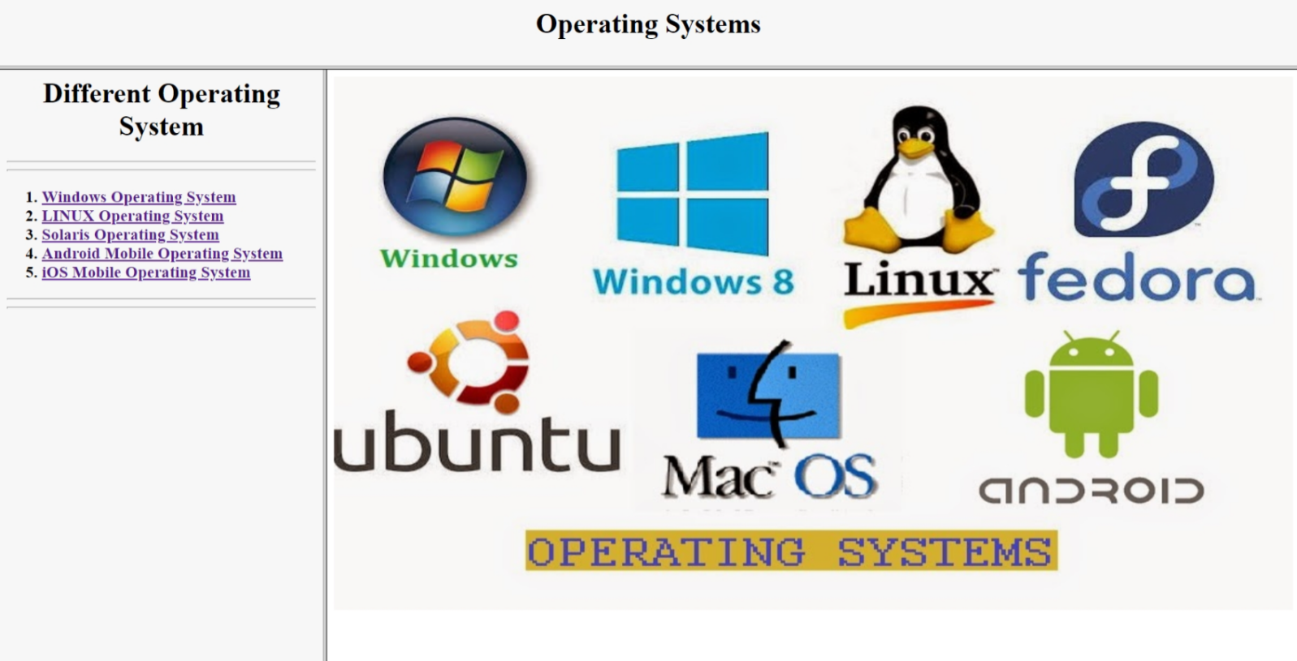

***Landing Page***

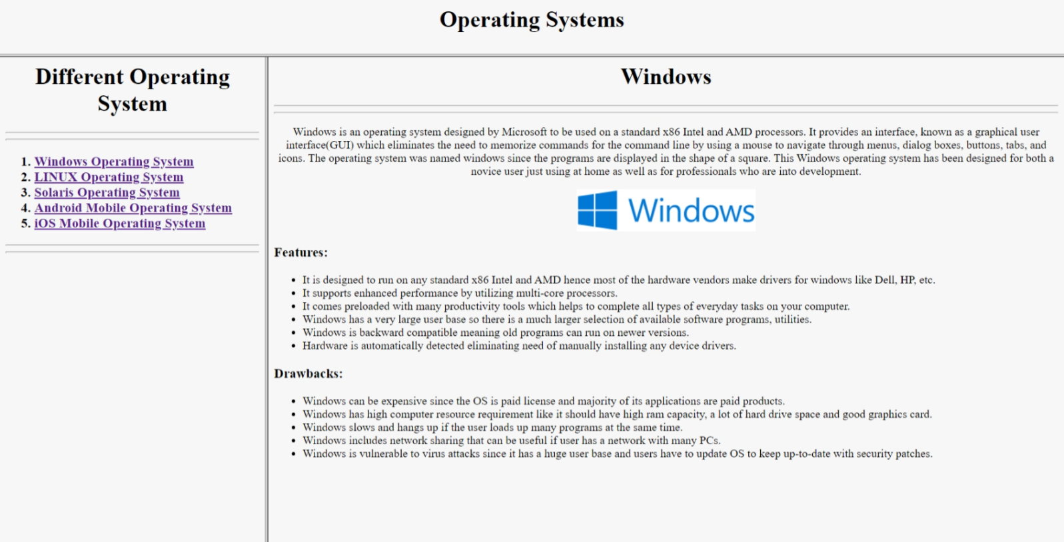

***Windows Operating System***

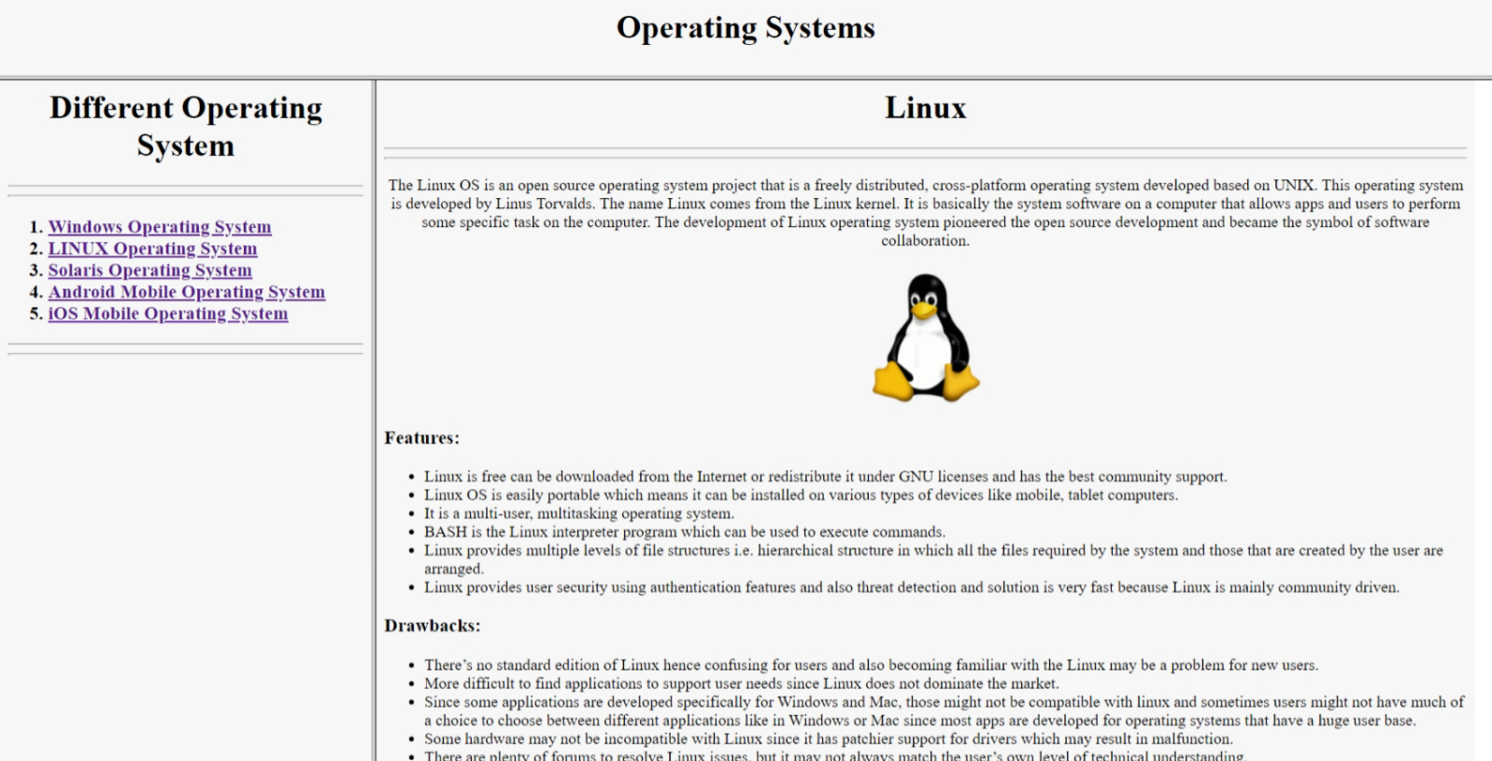

***Linux Operating System***

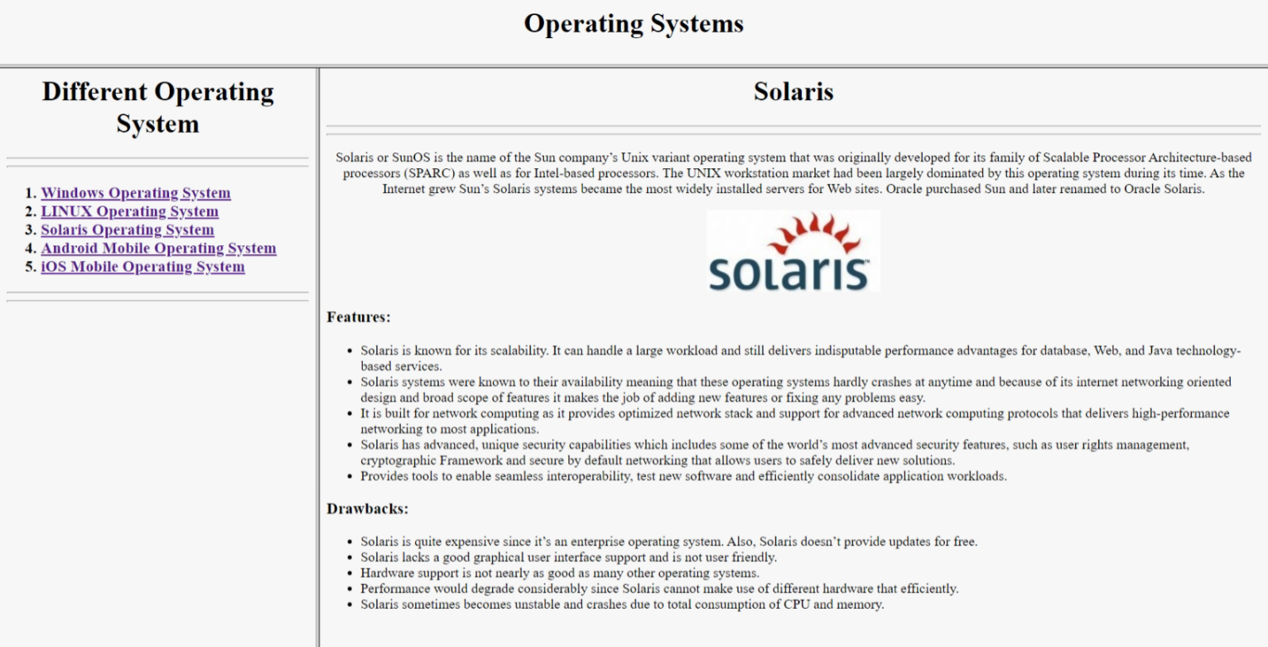

***Solaris Operating System***

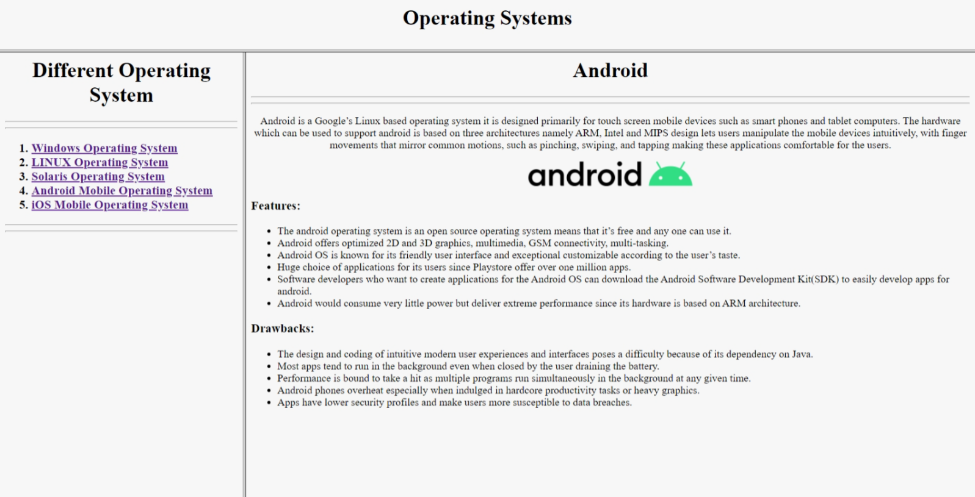

***Android Operating System***

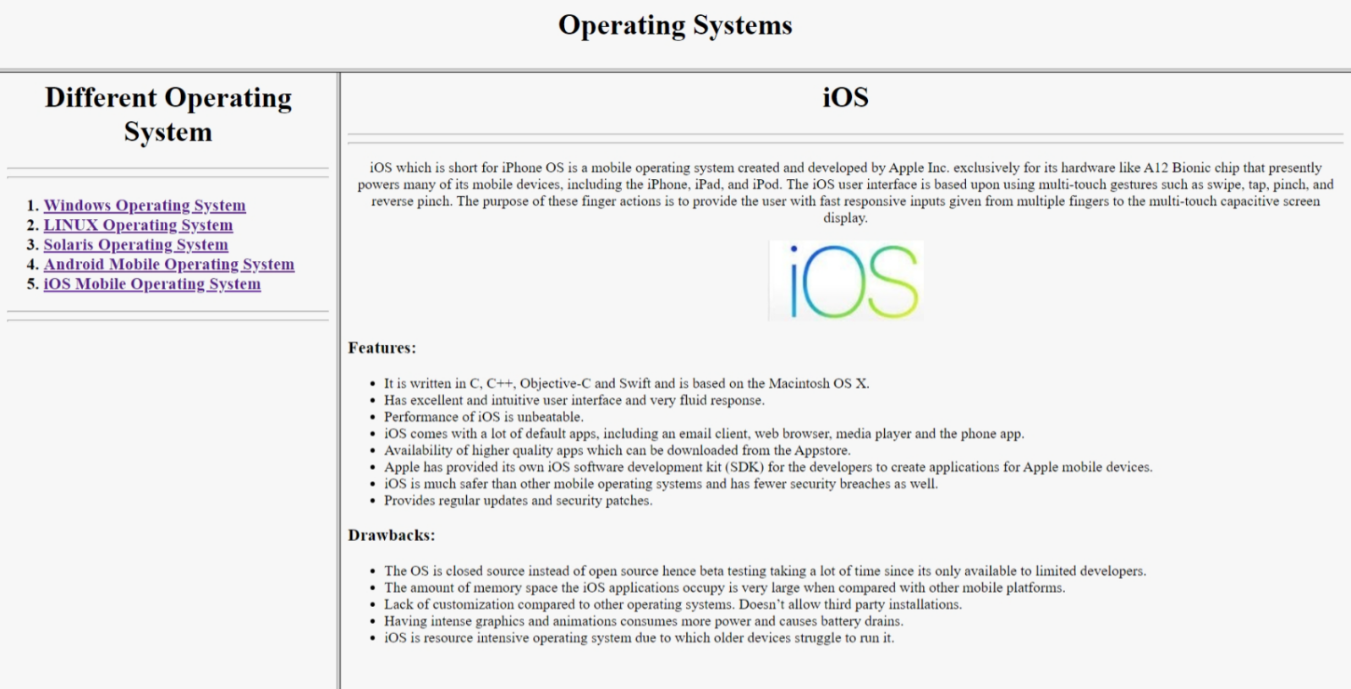

***iSO Operating System***

**Practical - 15**

**Objective:** Program to Prepare a web-page that contain all the control elements of form tag.

**Description:** 'Form elements' are the (usually interactive) controls whose values are submitted automatically with the http request that is initiated by clicking the "submit" button - even without javaScript. Most commonly this would be button , input , textarea and similar element types.

**Source Code:**

<html>

<head>

    <title>

        Registeration Form

    </title>

</head>

<body bgcolor="#f7f7f7">

    <h1 align="center">Registeration Form</h1>

    <hr>

    <hr>

    <br><br>

    <form>

        <label for="firstname">First name:</label>

        <input type="text" id="firstname" name="firstname">

        <br>

        <br>

        <label for="lastname">Last name:</label>

        <input type="text" id="lastname" name="lastname">

        <br>

        <br>

        <label for="Email">Email - Id:     </label>

        <input type="email" id="email" name="Email">

        <br>

        <br>

        <label for="passward">Passward:</label>

        <input type="password" id="passward" name="passward">

        <br>

        <br>

        <label for="gander">Gender: </label>

        <input type="radio" id="male" name="gender" checked value="male">

        <label for="male">Male</label>

        <input type="radio" id="female" name="gender" value="female">

        <label for="female">Female</label>

        <input type="radio" id="other" name="gender" value="other">

        <label for="other">Other</label><br><br>

        <label for="hobies">Hobbies:</label><br> <br>

        <input type="checkbox" id="checkbox" name="checkbox">Singing</input> <br>

        <input type="checkbox" id="checkbox" name="checkbox">Dancing</input> <br>

        <input type="checkbox" id="checkbox" name="checkbox">Book Reading</input> <br>

        <input type="checkbox" id="checkbox" name="checkbox">Listening Music</input> <br>

        <input type="checkbox" id="checkbox" name="checkbox">Listening Podcast</input> <br>

        <input type="checkbox" id="checkbox" name="checkbox">Writing</input> <br><br><br><br>

<button type="submit">Submit</button>

        <button type="reset">Reset</button>

        <hr>

        <hr>

    </form>

</body>

</html>

**Output:**

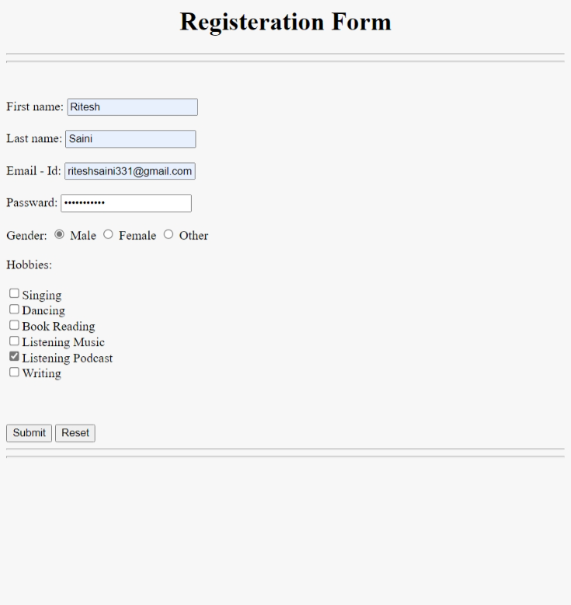

***Registrartion Form After Click Submit The Url Get The values***



***Like This***

***On Reset The All vaulues are Clear***

**Practical - 16**

**Objective:** Program to write something to a web-page using JavaScript: Lets write “Hello World” to a blank page using JavaScript.

**Description:** Javascript is used by programmers across the world to create dynamic and interactive web content like applications and browsers. JavaScript is so popular that it's the most used programming language in the world, used as a client-side programming language by 97.0% of all websites.

**Source Code:**

<html>

<head>

    <title>JavaScript</title>

</head>

<body>

<script language="javascript" type="text/javascript">

document.write("Welcome To JavaScript Programming <br><br> Hello World")

  </script>

</body>

</html>

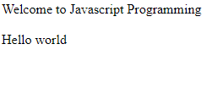**Output:**

***Welocome To JavaScript***

**Practical - 17**

**Objective:** Program to apply various CSS rules On a Web page.

**Description:** HTML (the Hypertext Markup Language) and CSS (**Cascading Style Sheets**) are two of the core technologies for building Web pages. HTML provides the structure of the page, CSS the (visual and aural) layout, for a variety of devices.

**Source Code:**

**index.html**

<html>

<head>

    <title>CSS</title>

    <style>

        body {

            background-image: url(https://backgroundcheckall.com/wp-content/uploads/2017/12/professional-background-images-for-websites-design-11.jpg);

        }

    </style>

    <link rel="stylesheet" href="16style.css">

</head>

<body>

    <h1 align="center">

        Operating System

    </h1>

 <p id="border" align="center">

        LINUX Operating System

   </p>

    <p align="center" style="background-color: rgba(55, 15, 235, 0.493); font-size: 24px;">

        Linux Type

    </p>

    <ul>

        <li id="doted">

            <dl>

                <dt>Red Hat Linux</dt>

                <dd>The RedHat Linux operating system is one of the relatively old GNU / Linux, offering

                    convenience, a fully graphical display mode starting at installation, and friendly usage.

                </dd>

            </dl>

        </li>

        <br>

        <li id="dash">

            <dl>

                <dt>Debian Linux</dt>

                <dd>TDebian is one type of various Linux operating systems that have been around for a long time since  1999 and continue to be developed regularly every year until now entering version 8.

                </dd>

            </dl>

        </li>

        <br>

        <li id="grove">

            <dl>

                <dt> Ubuntu Linux</dt>

                <dd>Ubuntu is a type of Linux operating system that is basically developed from Debian. The difference   is that this Ubuntu operating system can be used not only on server computers and admin computers but also can and is suitable for use on personal or personal computers. The Ubuntu project itself is  funded by Canonical Ltd (a company owned by Mark Shuttleworth).

                </dd>

            </dl>

        </li>

        <br>

        <li id="double">

            <dl>

                <dt>Linux Mint</dt>

                <dd>If Ubuntu was a development of Debian, Linux Mint is arguably the grandchild of Debian because it  was developed on the basis of Ubuntu. The Linux Mint operating system was developed for the purpose of personal or personal use (PC) and is divided into 2 variants namely CINNAMON and MATE.

                </dd>

            </dl>

        </li>

        <br>

        <li id="allborder">

            <dl>

                <dt>Fedora Linux</dt>

                <dd>Fedora (formerly called Fedora Core, sometimes also called Fedora Linux) is an RPM-based Linux distribution that is developed by the Fedora Project which is supported by the programming community  and sponsored by Red Hat. The latest version is Fedora 24.

                </dd>

            </dl>

        </li>

    </ul>

</body>

</html>

**style.css**

h1{

    color: aliceblue;

    background-color: rgba(221, 49, 49, 0.5) ;

    font-size: 64px;

}

#border{

    font-size: 36px;

    background-color: #00ffaa;

      border:4px solid rgb(71, 218, 255);

      color: aliceblue;

    background-color: rgba(00,00,00,0.5) ;

}

#doted{

    border-style: dotted;

    border-width: medium;

    font-size: 36px;

    color: aliceblue;

    background-color: rgba(00,00,00,0.5) ;

}

#dash{

     border-style: dashed;

    border-width: medium;

    font-size: 36px;

    color: aliceblue;

    background-color: rgba(00,00,00,0.5) ;

}

#grove

{

    border-style: groove;

    border-width: medium;

    font-size: 36px;

    color: aliceblue;

    background-color: rgba(00,00,00,0.5) ;

}

#double

{

    border-style:double;

    border-width: medium;

    font-size: 36px;

    color: aliceblue;

    background-color: rgba(00,00,00,0.5) ;

}

#allborder{

    border-top-style: dashed;

    border-left-style: dotted;

    border-right-style: groove;

    border-bottom-style: double;

    border-width: 4px;

    border-color: #00ffaa;

    color: aliceblue;

    background-color: rgba(00,00,00,0.5) ;

    font-size: 36px;

}

**Output:** 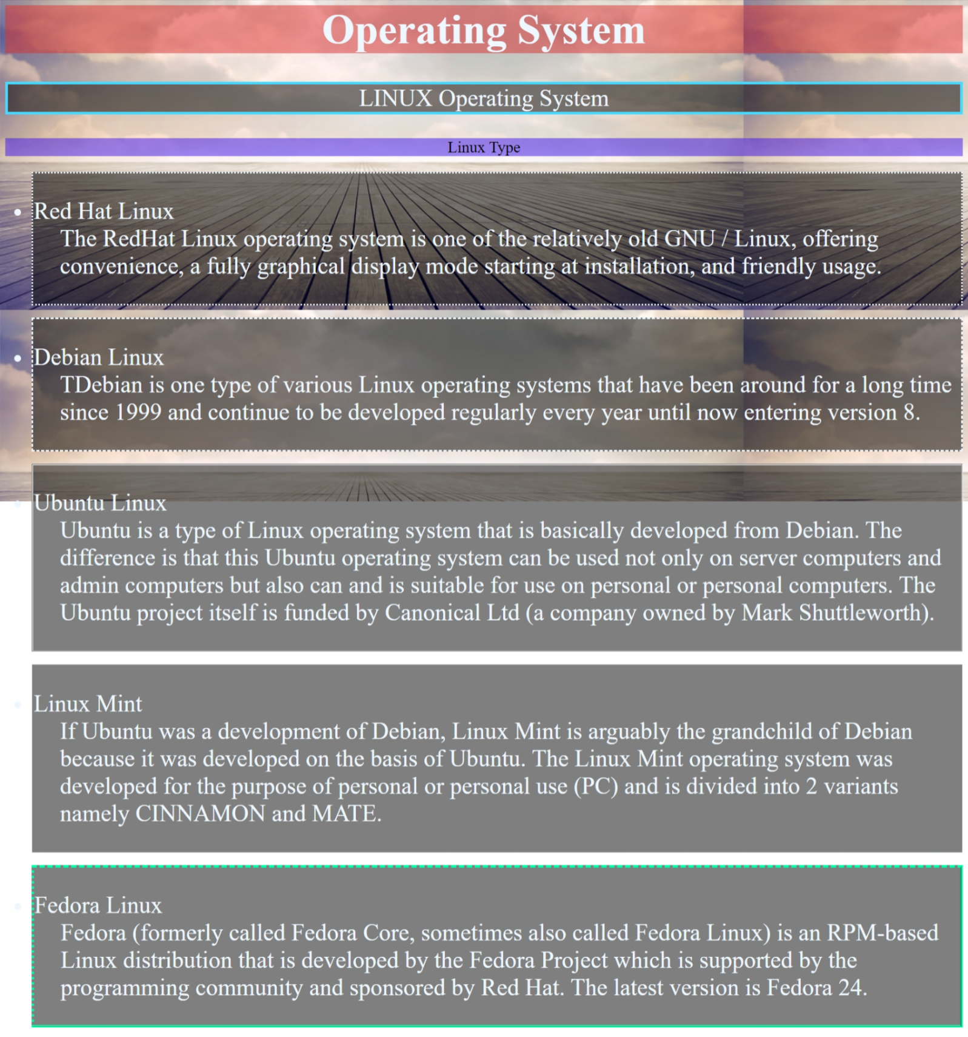

***CSS Properties***

**Practical - 18**

**Objective:** Program to to find the elements which present in both of the given array.

**Description:** Arrays are lists of any kind of data, including other arrays. Each item in the array has an index — a number — which can be used to retrieve an element from the array.

**Source Code:**

<html>

<head>

    <title>Comman Element</title>

</head>

<body bgcolor="#f7f7f7">

    <h1 align="Center">Common Elements</h1>

    <hr>

    <hr>

    <h2>Array 1 : [58,69,78,15,26,3,6,48,25,48,9,6,36]</h2>

    <h2>Array 2 : [78,52,64,35,26,96,25,544,63,0]</h2>

    <h3 id="output">Comman Element Are : </h3>

<hr><hr>

    <script>

        function check(arra1, arra2) {

            document.getElementById("output").innerHTML+= " [ "

            for (var i = 0; i < arra1.length; i++) {

                for (var j = 0; j < arra2.length; j++) {

                    if (arra1[i] === arra2[j]) {

                        document.getElementById("output").innerHTML+=arra1[i] + " , "

                    }

                }

            }

            document.getElementById("output").innerHTML+= " ] "

        }

        check([58,69,78,15,26,3,6,48,25,48,9,6,36], [78,52,64,35,26,96,25,544,63,0])

    </script>

</body>

</html>

**Output:**

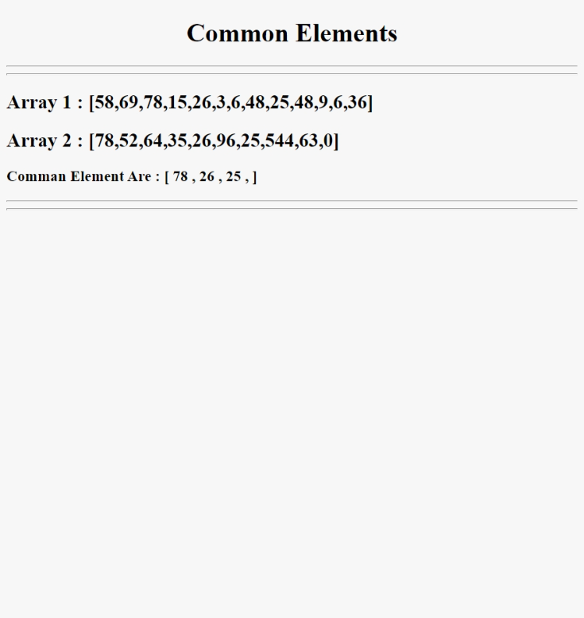

***Comman Elemrnts of Array***

**Practical - 19**

**Objective:** Write a JavaScript program to check whether all the digit in a given number are the same or not using function

**Description:** A function in JavaScript is similar to a procedure—a set of statements that performs a task or calculates a value, but for a procedure to qualify as a function, it should take some input and return an output where there is some obvious relationship between the input and the output.

**Source Code:**

<html>

<head>

    <title>Check whether all the digits in a given number are the same or not</title>

<style>

        #btn {

            background-color: blueviolet;

            color: white;

            width: 256px;

            height: 36px;

            border-radius: 15px;

            font-size: 18px;

        }

        #enternum {

            font-size: 24px;

            font-weight: 100;

        }

        #number {

            height: 36px;

            width: 256;

            border-radius: 24px;

        }

    </style>

</head>

<body align="center" bgcolor="#f7f7f7">

    <hr><hr>

    <h1>Check All Digits Are Same Or Not</h1>

    <hr><hr>

    <br><br><br><br>

    <label id="enternum">Enter Number: </label>

    <input type="number" name="number" id="number">

    <br><br>

    <button id="btn" onclick="check()"> Check</button>

    <h3 id="output"></h3>

    <script>

    function check() {

            var num = document.getElementById("number").value;

            var first = num % 10;

            var flag = -1;

            while (num) {

                if (num % 10 !== first) {

                    flag = 0;

                    break;

                }

                else {

                    flag = 1;

                }

                num = Math.floor(num / 10);

            }

            if (flag == 1) {

                document.getElementById("output").innerHTML = "All Digits Are Same"

            } else if (flag == 0) {

                document.getElementById("output").innerHTML = "Digits Are Not Same"

            }

            else {

                document.getElementById("output").innerHTML = "Please Enter A Number"

            }

        }

    </script>

</body>

</html>

**Output:**

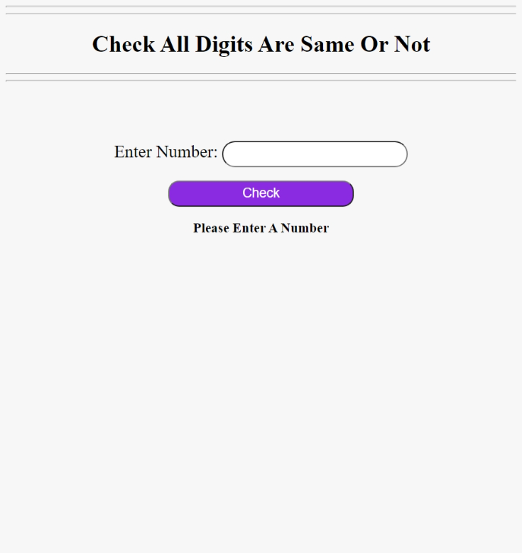

***When No Number is Entered***

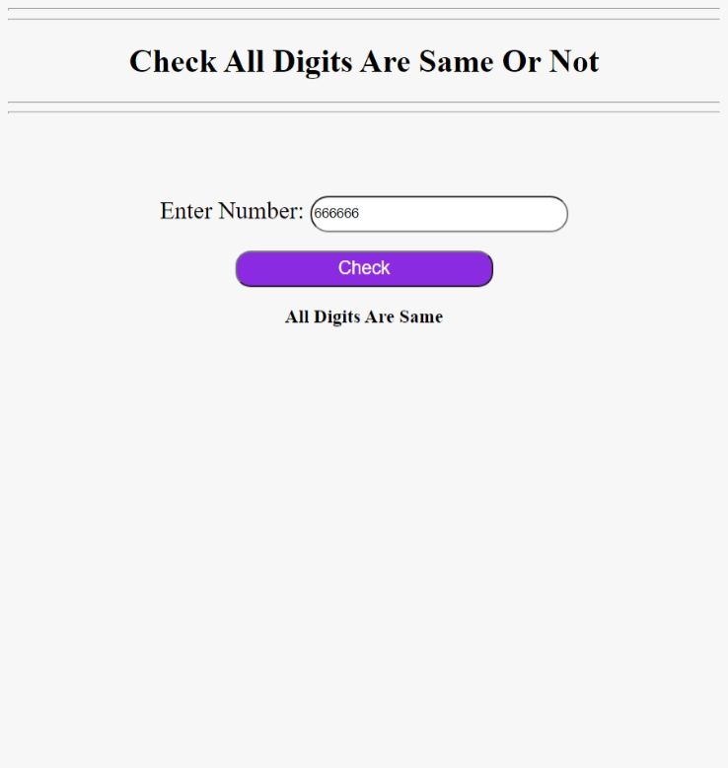

***When Digits Are Same***

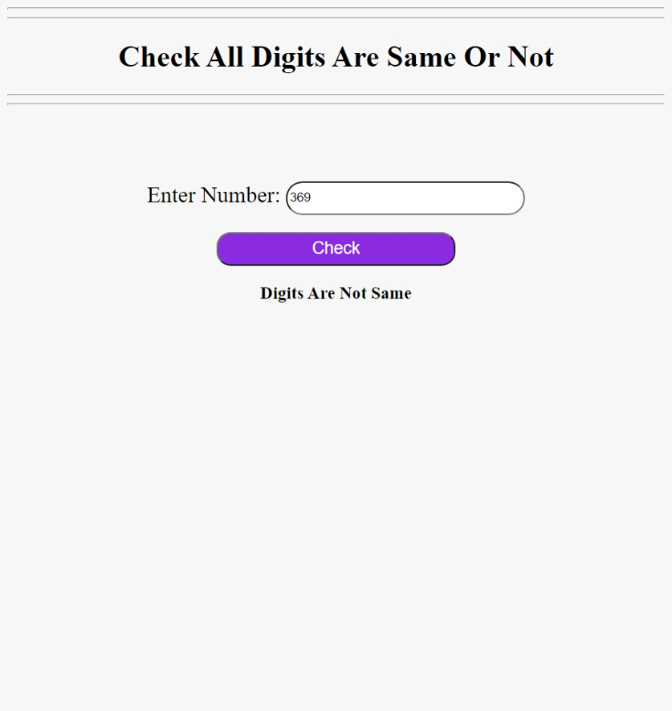

***When Digits Are Not Same***

**Practical - 20**

**Objective:** Program to set background color of a web page using CSS

**Description**: The background-color property sets the background color of an element. The background of an element is the total size of the element, including padding and border (but not the margin). Tip: Use a background color and a text color that makes the text easy to read.

**Source Code:**

<html>

<head>

    <title>Background Color</title>

    <style>

        body {

            background-color: #f7f7f7

        }

        h1 {

            text-align: center;

        }

        p {

            font-size: 18px;

        }

    </style>

</head>

<body>

    <h1>Background Color Change using CSS</h1>

    <hr>

    <hr>

    <h1>Definition and Usage</h1>

    <p>The background-color property sets the background color of an element.The background of an element is the total size of the element, including padding and border (but not themargin).

Tip: Use a background color and a text color that makes the text easy to read.</p>

    <p><b>Tip:</b> Use a background color and a text color that makes the text easy to read.</p>

    <h2>Example : </h2>

    <pre>

        body {

            background-color: #fefbd8;

          }

          h1 {

            background-color: #80ced6;

          }

          div {

            background-color: #d5f4e6;

          }

          span {

            background-color: #f18973;

          }

    </pre>

</body>

</html>

**Output:**

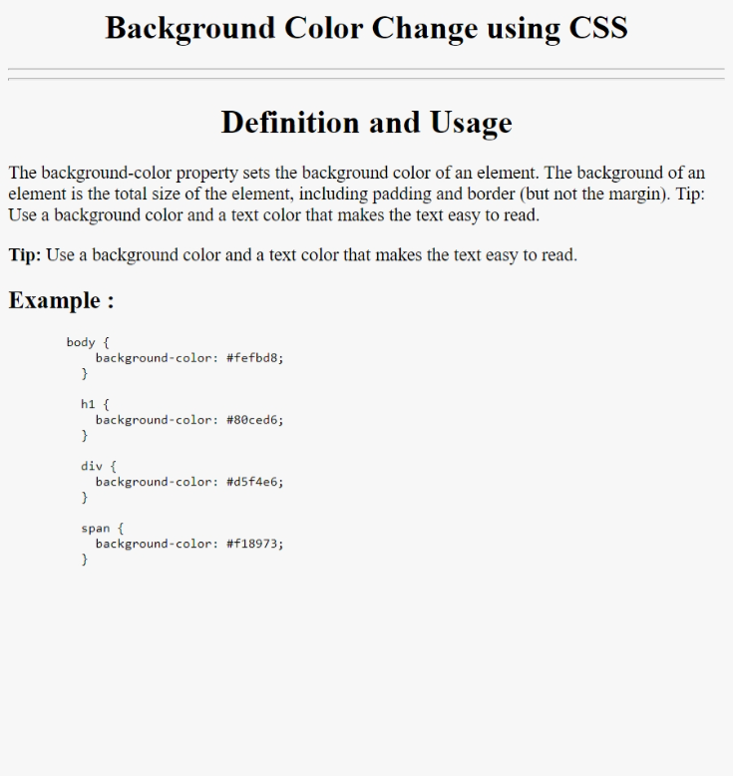

***Background Colour Using CSS***

**Practical - 21**

**Objective:** Program to prepare a collage website (contain at least 5 web-page).

**Description:** Seth Jai Parkash Mukand Lal Institute of Knowledge and Service is a chain of twenty eight institutions spread over Haryana & U.P and owe their existence to the munificent and philanthropic spirit of Seth Mukand Lal, a close adherent of Gandhi Ji. He came under the Gandhian influence in earlier twenties. Gandhi ji had fondly nick – named him “Pagla Bhagat”. Seth Mukand Lal reportedly bore the entire expenditure incurred in the holding of All India Congress Sessions on the banks of river Ravi, Lahore in 1929 where resolution for complete independence of India was adopted. Illiterate himself, he vowed to dispel the darkness of ignorance by opening educational institutions in the part of the country. Hence, he established Mukand Lal National High School at Abdulapur (now Yamuna Nagar) as the first institution of the Mukand chain.

**Source Code:**

***index.html***

<html>

<head>

    <title>JMIETI</title>

    <link rel="stylesheet" href="20style.css">

</head>

<body id="bg_image">

    <header>

        <a href="#"><img id="logo" src="http://www.jmieti.edu.in/wp-content/uploads/2018/05/mukand-logo.png"   alt="Mukand Logo">

        </a>

        <a href="#">

            <h1 id="collagename"> Jai Parkash Mukand Lal Innovative Engineering & Technology Institute

            </h1>

        </a>

        <nav id="navbar">

            <ol id="navitems">

                <li class="navitem"> <a href="#" class="navlinks activelink">Home</a> </li>

             <li class="navitem"> <a href="20facilities.html" class="navlinks">Centeral Facilities</a> </li>

                <li class="navitem"> <a href="20departments.html" class="navlinks">Departments</a> </li>

                <li class="navitem"> <a href="20Aboutus.html" class="navlinks">About Us</a> </li>

                <li class="navitem"> <a href="20Contactus.html" class="navlinks">Contact Us</a> </li>

            </ol>

        </nav>

    </header>

    <div id="text_box">

        <h1 id="text_content">

            Excellence Through Creativity And Innovation

        </h1>

        <br>

        <br>

        <button id="register_btn" >

            <a href="20Register.html" style="color: black;">Register Now</a>

        </button>

    </div>

    <footer>

        <p>&copy; 2021 Mukand. All Rights Reserved. || director@jmieti.edu.in || 8295905203, 208</p>

    </footer>

</body>

</html>

***Register.html***

<html>

<head>

    <title>JMIETI</title>

    <link rel="stylesheet" href="20style.css">

</head>

<body>

    <header>

        <a href="#"><img id="logo" src="http://www.jmieti.edu.in/wp-content/uploads/2018/05/mukand-logo.png"   alt="Mukand Logo">

        </a>

        <a href="#">

            <h1 id="collagename"> Jai Parkash Mukand Lal Innovative Engineering & Technology Institute

            </h1>

        </a>

        <nav id="navbar">

            <ol id="navitems">

                <li class="navitem"> <a href="20index.html" class="navlinks">Home</a> </li>

             <li class="navitem"> <a href="20facilities.html" class="navlinks">Centeral Facilities</a> </li>

                <li class="navitem"> <a href="20departments.html" class="navlinks">Departments</a> </li>

                <li class="navitem"> <a href="20Aboutus.html" class="navlinks">About Us</a> </li>

                <li class="navitem"> <a href="20Contactus.html" class="navlinks">Contact Us</a> </li>

            </ol>

        </nav>

    </header>

    <div id="registeration_form">

        <h1 style="text-align: center; font-family: 'Times New Roman', Times, serif;">Regiteration Form</h1>

        <hr>

        <hr>

        <br><br>

        <form id="form">

            <div class="form_items">

                <label for="fname"> <b>First Name:</b> </label>

                <input type="text" name="fname" id="fname">

            </div>

            <br><br>

            <div class="form_items">

                <label for="lname"><b>Last Name : </b></label>

                <input type="text" name="lname" id="lname">

            </div>

            <br><br>

            <div class="form_items">

                <label for="email"> <b>E-mail Id:</b></label>

                <input type="text" name="email" id="email">

            </div>

            <br><br>

            <div class="form_items">

                <label for="number"> <b>Phone Number:</b> </label>

                <input type="text" name="number" id="number">

            </div>

            <br><br><br><br>

            <div class="form_items">

                <button id="submit">

                    <a href="20index.html" style="color: black;">Register Now</a>

                </button>

            </div>

        </form>

         <br><br>

   <hr><hr>

<br><br>

    </div>

    <footer>

        <p>&copy; 2021 Mukand. All Rights Reserved. || director@jmieti.edu.in || 8295905203, 208</p>

    </footer>

</body>

</html>

***facilities.html***

<html>

<head>

    <title>JMIETI</title>

    <link rel="stylesheet" href="20style.css">

</head>

<body>

    <header>

        <a href="#"><img id="logo" src="http://www.jmieti.edu.in/wp-content/uploads/2018/05/mukand-logo.png"   alt="Mukand Logo">

        </a>

        <a href="#">

            <h1 id="collagename"> Jai Parkash Mukand Lal Innovative Engineering & Technology Institute

            </h1>

        </a>

        <nav id="navbar">

            <ol id="navitems">

                <li class="navitem"> <a href="20index.html" class="navlinks">Home</a> </li>

                <li class="navitem"> <a href="#" class="navlinks activelink">Centeral Facilities</a> </li>

                <li class="navitem"> <a href="20departments.html" class="navlinks">Departments</a> </li>

                <li class="navitem"> <a href="20Aboutus.html" class="navlinks">About Us</a> </li>

                <li class="navitem"> <a href="20Contactus.html" class="navlinks">Contact Us</a> </li>

            </ol>

        </nav>

    </header>

    <div>

        <h1 class="central_titel">Central Facilities</h1>

        <div class="card">

            <h2 class="card_titel">PHYSICAL INFRASTRUCTURE</h2>

            <br>

            <ul class="card_details">

                <li>Institute has a well equipped Seminar Hall.</li>

                <li>Institute has a 1500 seater Auditorium. </li>

                <li>Institute has 1000 seater Amphitheatre.</li>

                <li>Institute has digital classrooms with multimedia facility. </li>

                <li>Institute has 150 KW solar power plant. </li>

            </ul>

        </div>

        <div>

            <div class="card">

                <h2 class="card_titel">IT INFRASTRUCTURE</h2>

                <ul class="card_details">

                    <li>Wi-Fi Campus with above 100mbps </li>

                    <li>MATLAB Lab</li>

                    <li>Tablets on issue basis</li>

                    <li>Cloud Computing Lab </li>

                    <li>Mobile Apps Development Lab(Android and iOS)</li>

                    <li>Computer labs with latest configuration </li>

                </ul>

            </div>

            <div class="card">

                <h2 class="card_titel">DISPENSARY</h2>

                <ul class="card_details">

                    <li>College has an on-campus dispensary to facilitate students with first-aid and minor health   issues.   </li>

                    <li>There is a Doctor hired by college specially for this purpose who is avaliable during college    hours. </li>

                </ul>

            </div>

            <div class="card">

                <h2 class="card_titel">GYM </h2>

                <ul class="card_details">

                    <li>The campus are provided Gyms in boys common room of hostel.</li>

                    <li>We think a student must be highly skilled with proper health. </li>

                    <li>To make this requirement full-fill gyms are maintained with proper ventilation Systems and  well-equipped machines.</li>

                </ul>

            </div>

            <div class="card">

                <h2 class="card_titel">GAMES AND SPORTS FACILITIES

                </h2>

                <ul class="card_details">

                    <li>Extensive and well laid out fields for sports and games are available on the campus for the students. </li>

                    <li>Badminton courts, Volleyball courts etc. facilities are available to the students.</li>

                    <li>Trained sports personnel help the students to develop their interest in games and coach them to   acceptable standards </li>

                </ul>

            </div>

            <div class="card">

                <h2 class="card_titel">ENTERTAINMENT </h2>

                <ul class="card_details">

                    <li>The campus provided TV in Boys common room for their entertainment </li>

                </ul>

            </div>

            <div class="card">

                <h2 class="card_titel">CANTEEN

                </h2>

                <ul class="card_details">

                    <li>The facility of canteen is also provided in the college premises . </li>

                    <li> The canteen is that part of the campuswhere students can relax with their friends and the  canteen consists of a seperate cabin of staff . </li>

                    <li>Thecanteen provides the facility of healthy food and a friendly environment to make students comfortable in the campus.</li>

                </ul>

            </div>

            <div class="card">

                <h2 class="card_titel">BANK</h2>

                <ul class="card_details">

                    <li>

                        There is a branch of Oriental Bank of Commerce (OBC) with ATM near college campus. So if a student  needs money he can get it any time. </li>

                </ul>

            </div>

        </div>

        <footer>

         <p>&copy; 2021 Mukand. All Rights Reserved. || director@jmieti.edu.in || 8295905203, 208</p>

        </footer>

</body>

</html>

***departments.html***

<html>

<head>

    <title>JMIETI</title>

    <link rel="stylesheet" href="20style.css">

</head>

<body>

    <header>

        <a href="#"><img id="logo" src="http://www.jmieti.edu.in/wp-content/uploads/2018/05/mukand-logo.png"  alt="Mukand Logo">

        </a>

        <a href="#">

            <h1 id="collagename"> Jai Parkash Mukand Lal Innovative Engineering & Technology Institute

            </h1>

        </a>

        <nav id="navbar">

            <ol id="navitems">

                <li class="navitem"> <a href="20index.html" class="navlinks">Home</a> </li>

                <li class="navitem"> <a href="20facilities.html" class="navlinks">Centeral Facilities</a> </li>

                <li class="navitem"> <a href="#" class="navlinks activelink">Departments</a> </li>

                <li class="navitem"> <a href="20Aboutus.html" class="navlinks">About Us</a> </li>

                <li class="navitem"> <a href="20Contactus.html" class="navlinks">Contact Us</a> </li>

            </ol>

        </nav>

    </header>

    <div>

        <h1 class="central_titel">Departments</h1>

        <div class="card">

            <h2 class="card_titel">Computer Science Engineering</h2>

            <img class="card_image" src="Deptt-CSE.jpg" alt="Department of Compuer Science">

            <ul class="card_details">

                <li>Computer science or computing   science (sometimes abbreviated CS) is the study of the theoretical foundations of information and  computation,  and of practical  techniques for their implementation and application in computer systems..</li>

                <li>It is frequently described as the  systematic study of algorithmic processes that create, describe, and transform information. </li>

                <li>Computer science has many sub-fields;  some, such as  computer graphics, emphasize the computation of specific results, while others, such as  computational complexitytheory, studythe properties of computational problems. Still others focus on the challenges in implementing computations.</li>

                <li> For example, programming language theory studies approaches to describe computations, while computer   programming applies specific programming languages to solve specific computational problems, and human-computer interaction focuses on the challenges in making computers and computations useful, usable, and universally accessible to  people. </li>

                <li> The general public sometimes confuses computer science with careers that deal with computers (such as information technology), or think that it relates to their own experience of computers, which typically involves activities such as gaming, web-browsing, and word-processing.</li>

                <li> However, the focus of computer science is more on

                   understanding the properties of the programs used to implement software such as games andweb-browsers, and using that understanding to create new  programs or improve existing ones.</li>

            </ul>

        </div>

        <div>

            <div class="card">

                <h2 class="card_titel">Civil Engineering</h2>

                <img class="card_image" src="Deptt-Civil.jpg" alt="Department of Civil">

                <ul class="card_details">

                    <li>Computer science or computing

                        Civil engineering is the broadest of the engineering fields.</li>

                    <li> Civil engineering focuses on the infrastructure of   the world which include Water works, Sewers, Dams, Power Plants, Transmission Towers/Lines, Railroads, Highways,   Bridges, Tunnels, Irrigation Canals, River  Navigation, Shipping Canals, Traffic Control, Mass Transit, Airport Runways, Terminals,Industrial Plant   Buildings, Skyscrapers, etc.</li>

                    <li> Among the important subdivisions of the field are construction engineering, irrigation

 engineering,  transportation engineering, soils and  foundation engineering, geodetic engineering, hydraulic engineering, and coastal and ocean

engineering.</li>

                </ul>

            </div>

            <div class="card">

                <h2 class="card_titel">Applied Science</h2>

                <img class="card_image" src="applied.jpg" alt="Department of Applied Science">

                <ul class="card_details">

                    <li>Computer science or computing  Department cover the subjects /areas of Applied Physics and Applied Chemistry</li>

                    <li>It has highly Qualified Faculty. </li>

                    <li>The Department has  the following well-developed laboratories- Applied Physics and Applied Chemistry .</li>

                    <li>The equipment in the Applied Physics laboratories  includes traveling microscopes, telescopes,spectrometer,sensitive galvanometer,cathoderay oscilloscope etc.</li>

                   <li> The equipment in the Applied Chemistry laboratories includes conductivity bridge ,water analysis kit,equipment like electronic balance,viscometer,flash point  apparatus etc are available.</li>

                    <li>Computer labs with latest configuration </li>

                </ul>

            </div>

        </div>

        <footer>

          <p>&copy; 2021 Mukand. All Rights Reserved. || director@jmieti.edu.in || 8295905203, 208</p>

        </footer>

</body>

</html>

***21Aboutus.html***

<html>

<head>

    <title>JMIETI</title>

    <link rel="stylesheet" href="20style.css">

</head>

<body>

    <header>

        <a href="#"><img id="logo" src="http://www.jmieti.edu.in/wp-content/uploads/2018/05/mukand-logo.png" alt="Mukand Logo">

        </a>

        <a href="#">

            <h1 id="collagename"> Jai Parkash Mukand Lal Innovative Engineering & Technology Institute

            </h1>

        </a>

        <nav id="navbar">

            <ol id="navitems">

                <li class="navitem"> <a href="20index.html" class="navlinks">Home</a> </li>

             <li class="navitem"> <a href="20facilities.html" class="navlinks">Centeral Facilities</a> </li>

                <li class="navitem"> <a href="20departments.html" class="navlinks">Departments</a> </li>

                <li class="navitem"> <a href="#" class="navlinks activelink">About Us</a> </li>

                <li class="navitem"> <a href="20Contactus.html" class="navlinks">Contact Us</a> </li>

            </ol>

        </nav>

    </header>

    <h1 class="central_titel">About JMIETI</h1>

    <div class="card">

        <div class="card_sub_titel">

            <h1>VISION</h1>

            <h2>"Excellence Through Creativity And Innovation"</h2>

        </div>

        <img class="card_image" src="about.jpg" alt="Collage Photo">

        <div class="card_sub_titel">

            <h1>MISSON</h1>

            <h2>"To Produce World Class Endinners, Managers And Technologies with triaining Head ,Heart and Hands Employable Anywhere in the world"</h2>

        </div>

        <p class="card_details">Jai Parkash Mukand Lal Innovative Engineering & Technology Institute was established in the year of 2012 and located at Chota Bans in Yamuna Nagar city of Haryana.

            <br>

            <br>

            JMIETI is affiliated to Kurukshetra University and approved by All India Council for Technical Education (AICTE).

            <br>

            <br>

            JMIETI is an institute dedicated to effectively develop highly professional individuals in the field of  Engineering & Technology.

            <br>

            <br>

            Jai Parkash Mukand Lal Innovative Engineering & Technology Institute offers an undergraduate program like  Bachelor of Technology in 3 different streams at UG level.

        </p>

    </div>

    <footer>

        <p>&copy; 2021 Mukand. All Rights Reserved. || director@jmieti.edu.in || 8295905203, 208</p>

    </footer>

</body>

</html>

***21Contactus.html***

<html>

<head>

    <title>JMIETI</title>

    <link rel="stylesheet" href="20style.css">

</head>

<body>

    <header>

        <a href="#"><img id="logo" src="http://www.jmieti.edu.in/wp-content/uploads/2018/05/mukand-logo.png"  alt="Mukand Logo">

        </a>

        <a href="#">

            <h1 id="collagename"> Jai Parkash Mukand Lal Innovative Engineering & Technology Institute

            </h1>

        </a>

        <nav id="navbar">

            <ol id="navitems">

                <li class="navitem"> <a href="20index.html" class="navlinks">Home</a> </li>

             <li class="navitem"> <a href="20facilities.html" class="navlinks">Centeral Facilities</a> </li>

                <li class="navitem"> <a href="20departments.html" class="navlinks">Departments</a> </li>

                <li class="navitem"> <a href="20Aboutus.html" class="navlinks">About Us</a> </li>

                <li class="navitem"> <a href="#" class="navlinks activelink">Contact Us</a> </li>

            </ol>

        </nav>

    </header>

    <div>

        <h1 class="central_titel">Contact US</h1>

        <div class="card">

            <div class="contact" style="margin-left: 5px; font-size: 18px;">

                <p>For any type of information about admission etc. Please contact given below

                    address or phone numbers. And for online information please click on the E-Mail link given below and send a mail.</p>

                <p><strong>Address :</strong> &nbsp; &nbsp; Chota Bans, Radaur-135133 (Distt. Yamuna Nagar) Haryana</p>

                <p><strong>E-Mail :</strong> &nbsp; &nbsp;&nbsp;&nbsp;&nbsp; hrdjmieti@gmail.com,

                    director@jmieti.edu.in<br>

            <strong>Phone : &nbsp;&nbsp;&nbsp;&nbsp; &nbsp; </strong>8295905203, 8295905208<br>

                    <strong>Website :</strong>&nbsp;&nbsp;&nbsp;&nbsp;&nbsp;<a

                        href="https://www.jmieti.edu.in">www.jmieti.edu.in</a>

                </p>

                <br><br>

                <h1 class="card_titel">Query Form</h1>

                <br><br>

                <form id="form">

                    <div class="form_items">

                        <label for="fname"> <b>First Name:</b> </label>

                        <input type="text" name="fname" id="fname">

                    </div>

                    <br><br>

                    <div class="form_items">

                        <label for="lname"><b>Last Name : </b></label>

                        <input type="text" name="lname" id="lname">

                    </div>

                    <br><br>

                    <div class="form_items">

                        <label for="email"> <b>E-mail Id :</b></label>

                        <input type="text" name="email" id="email">

                    </div>

                    <br>

                    <br>

                    <div class="form_items">

                        <label for="subject"> <b>Subject : </b> </label>

                        <input type="text" name="subject" id="subject">

                    </div>

                    <br><br>

                    <div class="form_items">

                        <label for="msg"> <b>Query : </b> </label>

                        <textarea cols="40" rows="10" name="msg" id="msg">

                            </textarea>

                    </div><br><br>

                    <div class="form_items">

                        <button id="submit">

                            <a href="20index.html" style="color: black;">Submit</a>

                        </button>

                    </div>

                </form>

            </div>

        </div>

    </div>

    <footer>

        <p>&copy; 2021 Mukand. All Rights Reserved. || director@jmieti.edu.in || 8295905203, 208</p>

    </footer>

</body>

</html>

***21style.css***

body {

  width: 100%;

  display: inline;

}

a {

  text-decoration: none;

}

header {

  width: 100%;

  align-items: center;

  background-color: honeydew;

}

#logo {

  margin: 12px;

  width: 150px;

}

#collagename {

  display: inline;

  color: #184bab;

  float: right;

  text-align: center;

  width: 85%;

  font-family: "Times New Roman", Times, serif;

}

#navbar {

  background-color: black;

  color: white;

  padding: 6px;}

#navitems {

  margin-left: 96px;

  list-style: none;

  font-size: 16px;

  font-family: "Times New Roman", Times, serif;

}

.navitem {

  display: inline;

  font-size: 18px;

  margin-left: 24px;

  margin-right: 24px;

}

.navlinks {

  text-decoration: none;

  color: white;

  padding: 12px 52px;

  border-radius: 36px;

}

.navitem :hover {

  background-color: white;

  color: black;

}

.activelink {

  background-color: white;

  color: black;

}

#bg_image {

  background-image: url("collage_front.png");

  background-repeat: no-repeat;

  background-size: cover;

}

#text_box {

    margin: 180px 256px;

  background-color: rgba(0, 0, 0, 0.527);

  color: white;

  padding: 50px;

  border-radius: 25px;

  text-align: center;

  font-size: 18px;

}

#text_content {

  display: contents;

}

#register_btn {

  background-color: white;

  color: black;

  height: 48px;

  width: 256px;

  font-size: 24px;

  border-radius: 24px;

  font-family: "Times New Roman", Times, serif;

}

footer {

  background-color: black;

  color: white;

  align-self: baseline;

  height: 48px;

  text-align: center;

  padding: 6px;

}

#registeration_form {

  border-radius: 25px;

  border: #020a1abb solid 4px;

  margin: 56px 226px;

  background-color: rgba(0, 0, 0, 0.438);

  background-image: url("collage_front.png");

  background-size: cover;

  color: white;

}

label {

  font-size: 20px;

  float: left;

  background-color: white;

  color: black;

  padding: 12px;

  width: 220px;

  text-align: center;

  font-size: 24px;

  border-radius: 24px;

  font-family: "Times New Roman", Times, serif;

}

#form {

  margin: 12px 96px;

}

input {

  border-radius: 12px;

  width: 512px;

  height: 48px;

  float: right;

}

.form_items {

  display: inline-block;

  width: 100%;

}

#submit {

  background-color: white;

  color: black;

  height: 48px;

  width: 256px;

  font-size: 24px;

  border-radius: 24px;

  font-family: "Times New Roman", Times, serif;

  margin-left: 256px;

}

.central_titel {

  margin: 24px 256px;

  padding: 12px;

  background-color: black;

  color: white;

  font-size: 24px;

  border-radius: 24px;

  font-family: "Times New Roman", Times, serif;

  text-align: center;

  opacity: 0.6;

}

.card {

  margin: 24px 224px;

  padding: 24px;

  border: black solid 6px;

  border-radius: 24px;

}

.card_titel {

  background-color: black;

  opacity: 0.6;

  color: white;

  padding: 12px;

  margin: 6px 196px;

  font-size: 24px;

  border-radius: 24px;

  font-family: "Times New Roman", Times, serif;

  text-align: center;

}

.card_details {

  margin-left: 12px;

  font-size: 24px;

  font-family: "Times New Roman", Times, serif;

}

.card_image {

  align-items: center;

  margin: 24px 120px;

  height: 360px;

  width: 720px;

  border-radius: 50px;

}

.card_sub_titel {

  background-color: black;

  opacity: 0.6;

  color: white;

  padding: 6px;

  margin: 6px 48px;

  border-radius: 24px;

  font-family: "Times New Roman", Times, serif;

  text-align: center;

}

#msg {

  border-radius: 12px;

  width: 512px;

  float: right;

  border: black solid 2px;

}

**Output:**

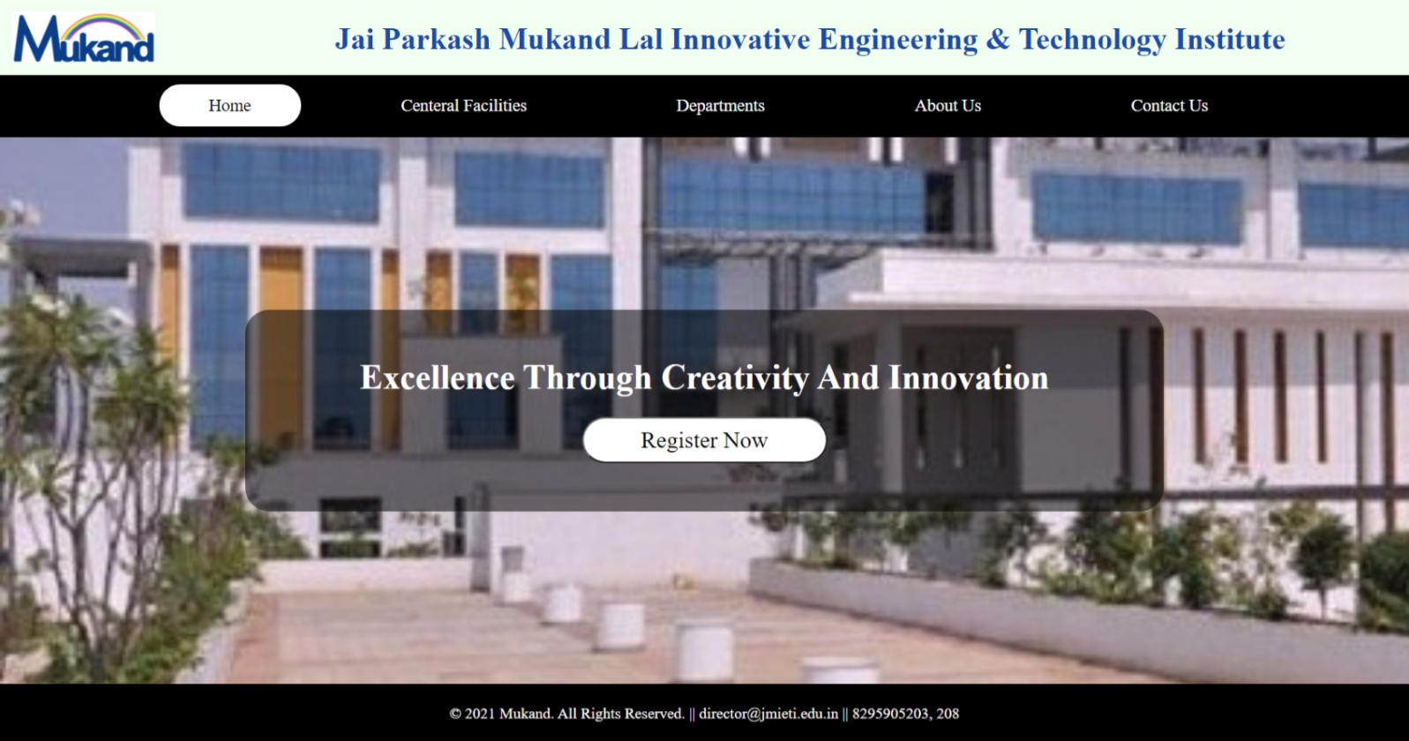

***Home Page***

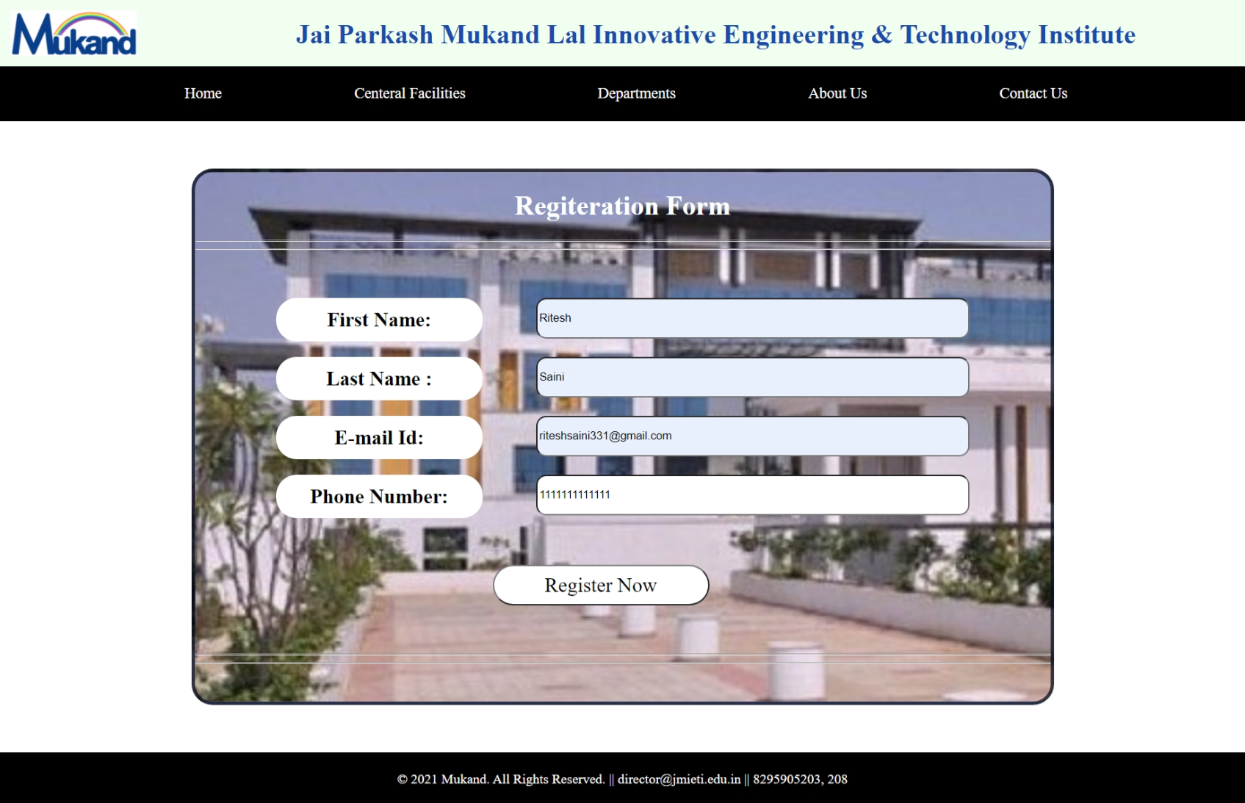

***Registration Page***

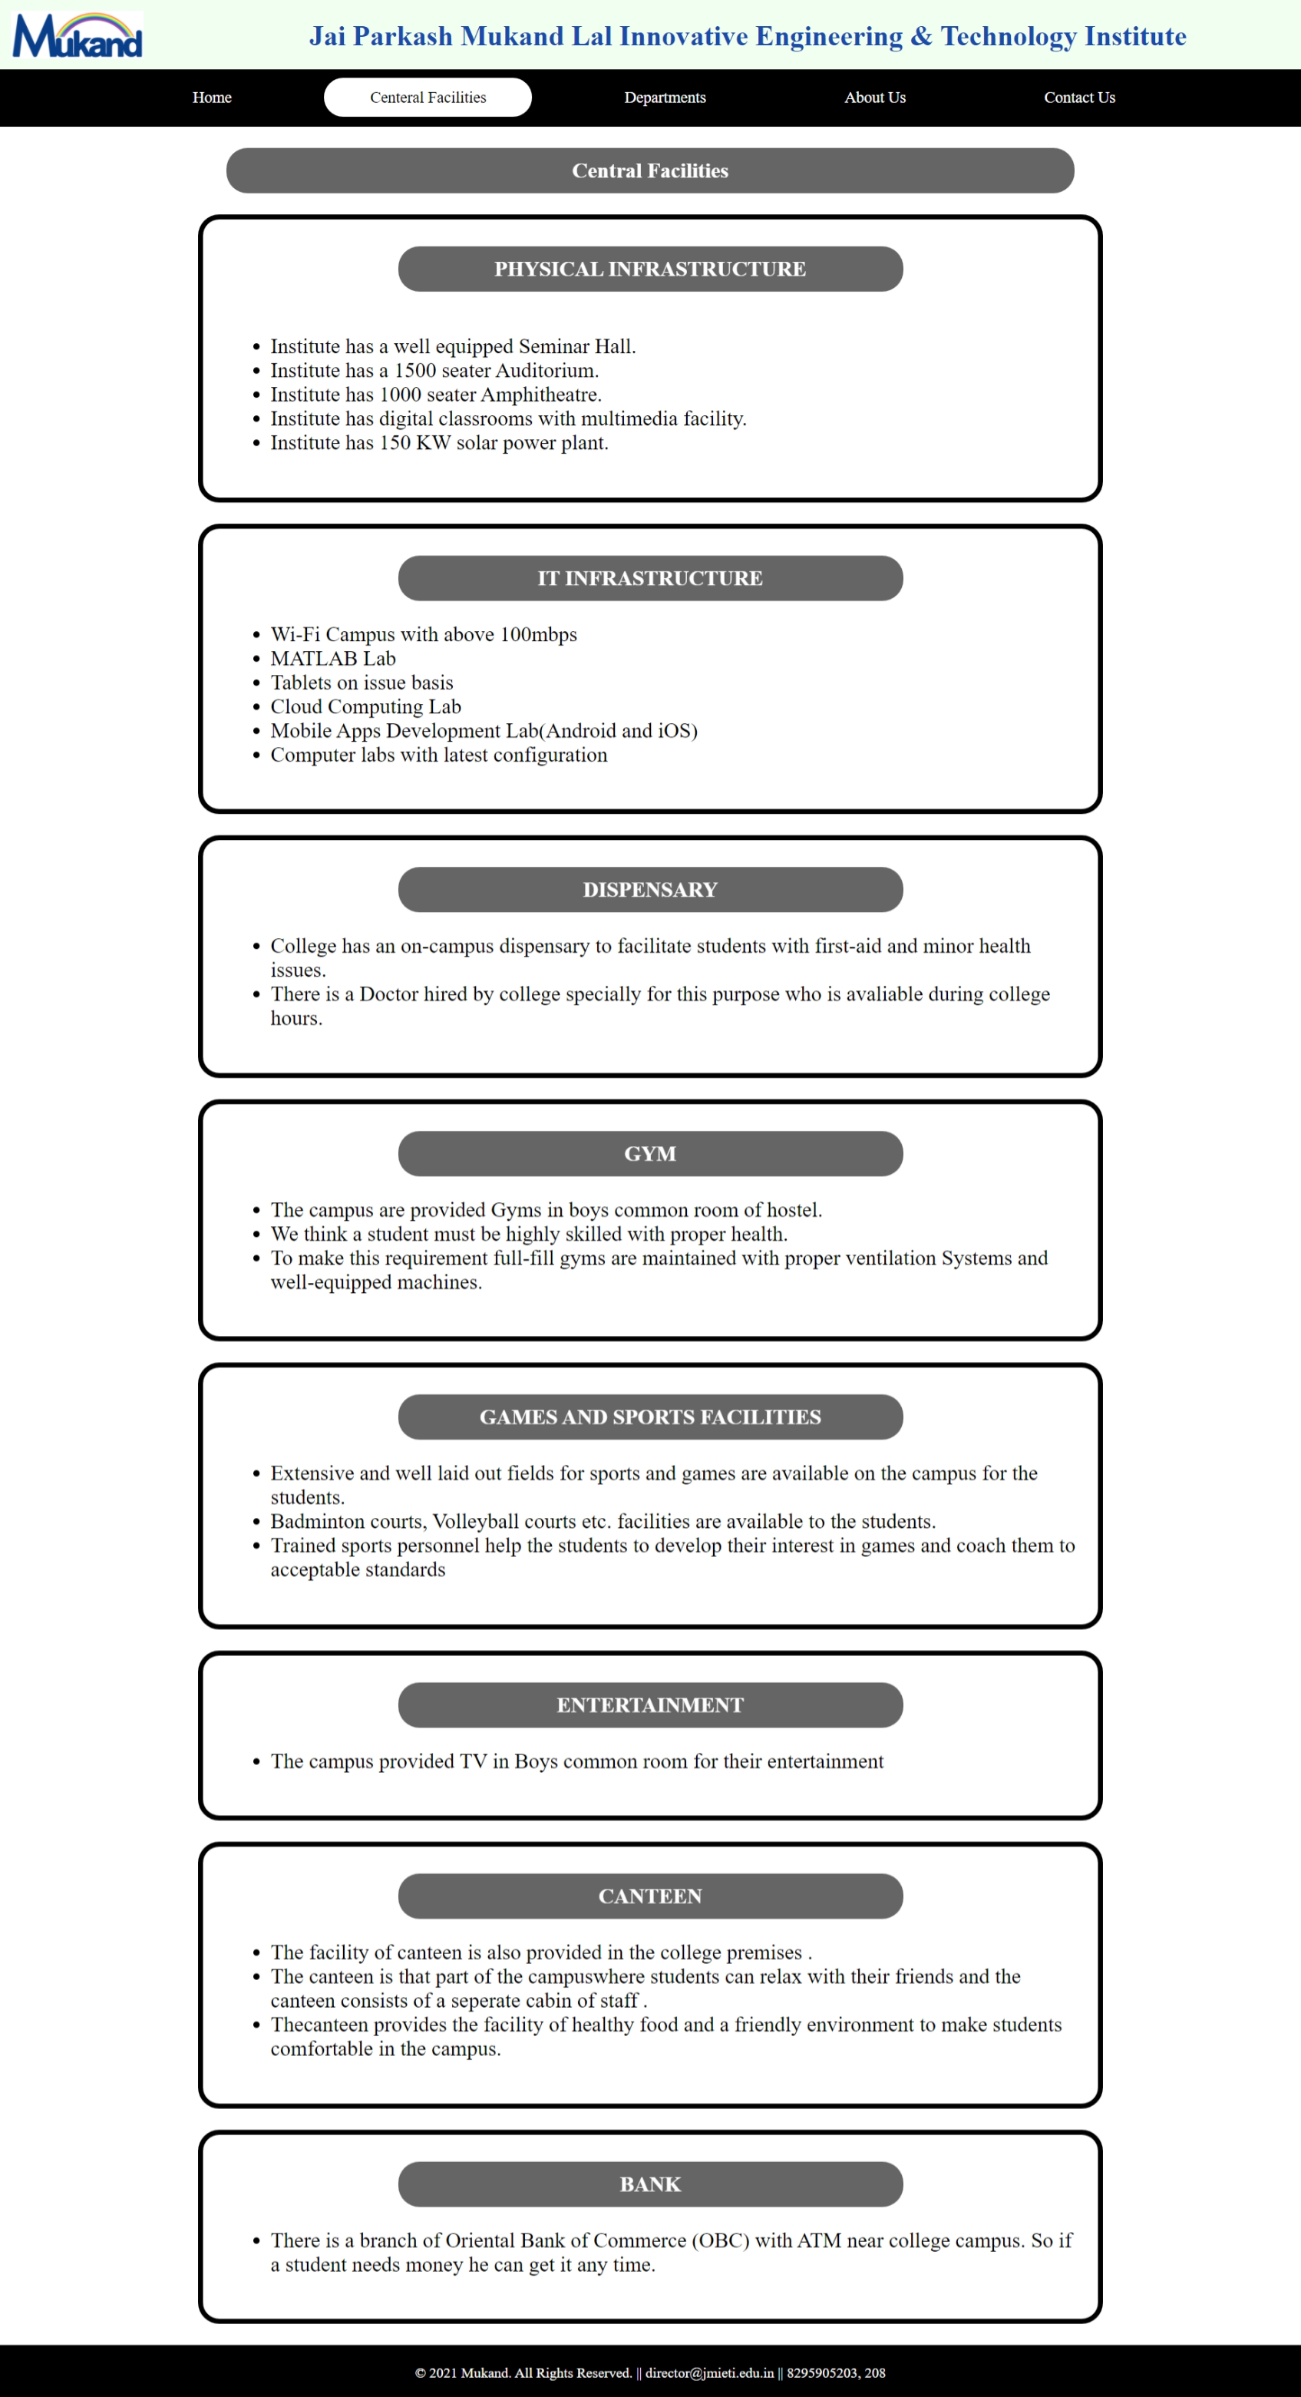

***Central Facilities***



***Central Facilities***

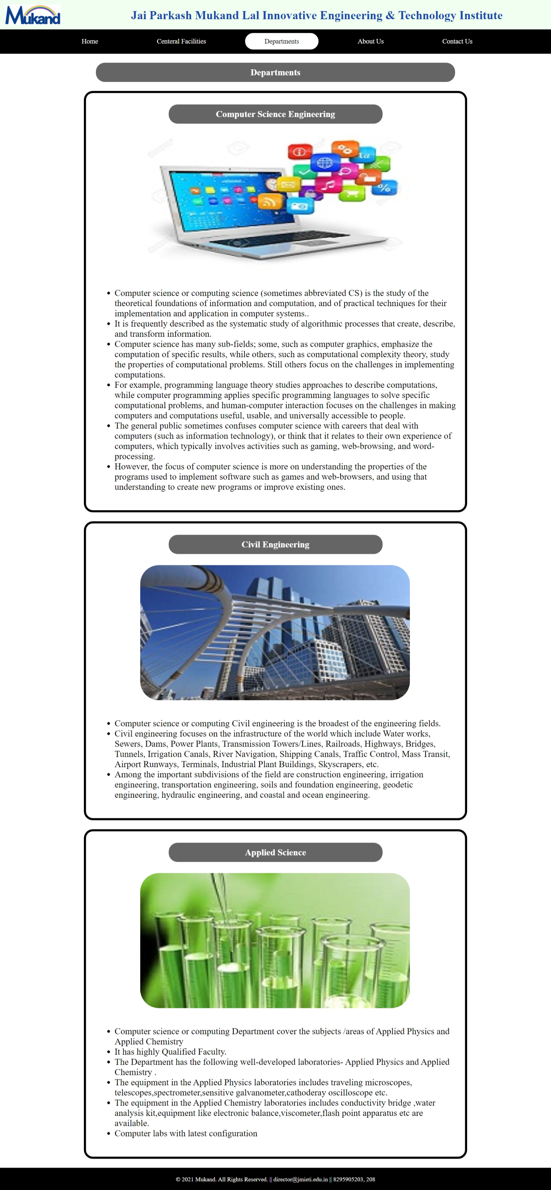

***Departments***



***Departments***

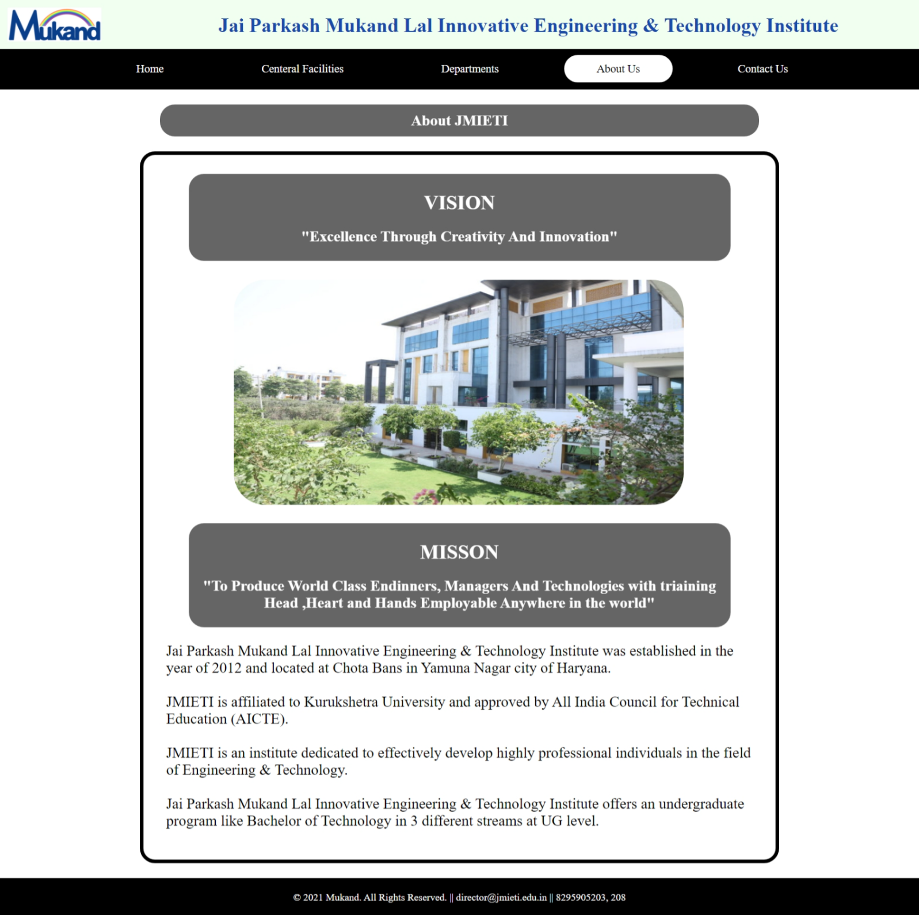

***About Us***

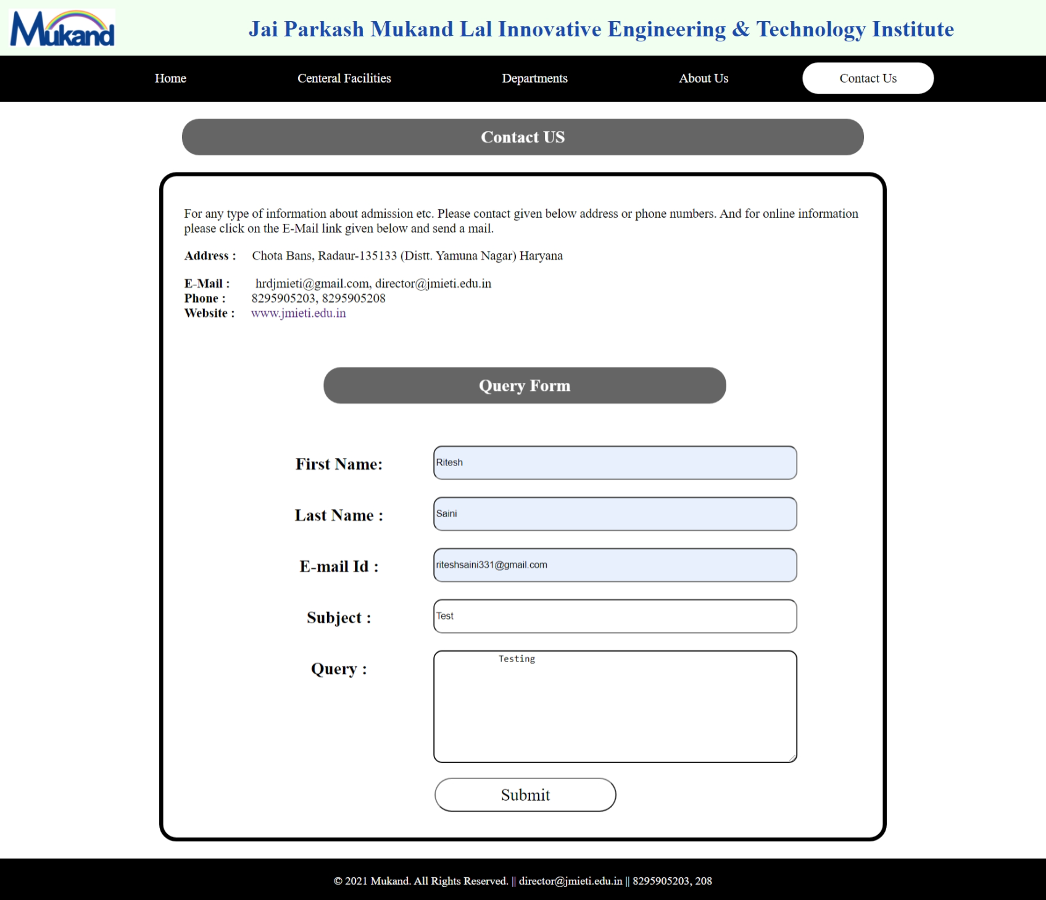

***Contact Us***

**PRACTICAL-5**

**Objective:** Create a document that uses multiple <BR> and <P> tags, and put returns between <PRE> tags to add blank lines to your document see if your browsers senders them differently.

**Description:** The Line Break element. The <br> HTML element produces a line break in text (carriage-return). It is useful for writing a poem or an address, where the division of lines is significant.

Tag omission

Permitted content

Implicit ARIA role

Permitted parents

The Paragraph element. The <p> HTML element represents a paragraph. Paragraphs are usually represented in visual media as blocks of text separated from adjacent blocks by blank lines and/or first-line indentation, but HTML paragraphs can be any structural grouping of related content, such as images or form fields.

The Preformatted Text element. The <pre> HTML element represents preformatted text which is to be presented exactly as written in the HTML file. The text is typically rendered using a non-proportional, or monospaced, font. Whitespace inside this element is displayed as written.

**Source Code:**

<!DOCTYPE html>

<html>

<head>

<title></title>

</head>

<body>

<center><h1>Business Letter Format</h1></center><hr size="2" noshade="" width="40%">

<p>

Company, Inc.<br>

123 Alphabet Drive<br>

Los Angeles, California 90002<br><br>

15 October 2016

</p>

<p>

Mr. John Doe<br>

Customer Service Representative<br>

Widgets Galore, Inc.<br>

987 Widget Street<br>

Miami, Florida 33111<br>

</p>

<p>Dear Mr. Doe: </p>

<p>

I am writing you concerning a recent purchase of widgets. Approximately two weeks ago, on October 1, I ordered a total of 50 widgets for Company, Inc. via the Widgets Galore client webpage. I received an email notification two days later confirming the receipt of payment and the shipment of the widgets. According to your website, shipments should reach their destination within 3-5 business days of being sent, but I have yet to receive the widgets. Do you have any information on what may have happened to delay the shipment or where the shipment is currently?

<pre></pre>

I have worked with Widgets Galore, Inc. in the past and have the greatest confidence in your products and customer service. We need the shipment of widgets soon, however, and I hoped you might be able to provide me with an idea of when I can expect them. Thank you in advance for any help you might be able to offer.

</p>

<p>Sincerely,</p>

<p>

Sam Brown<br>

Vice President of Company, Inc.<br>

555-555-5555<br>

s.brown@companyinc.com<br>

</p>

</body>

</html>

**OUTPUT:**

